**START OF LOOP/CYCLE**

1. EXTREME SOLUTION - HASH MAP<Node*, int>
   1. 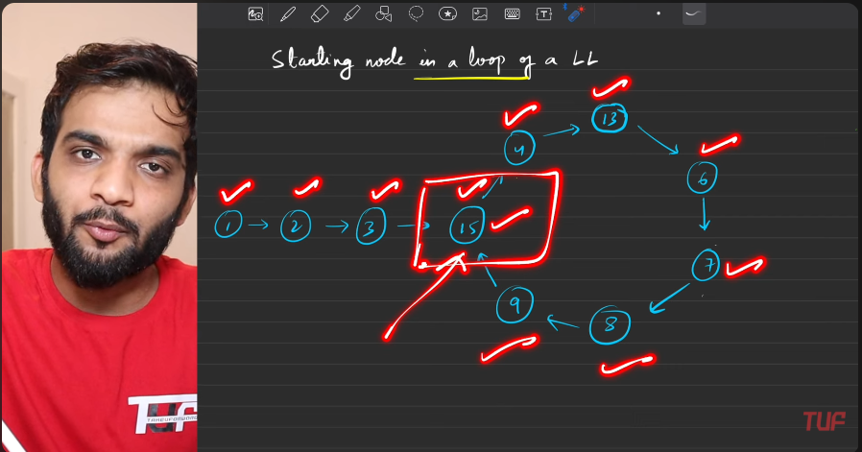
   2. 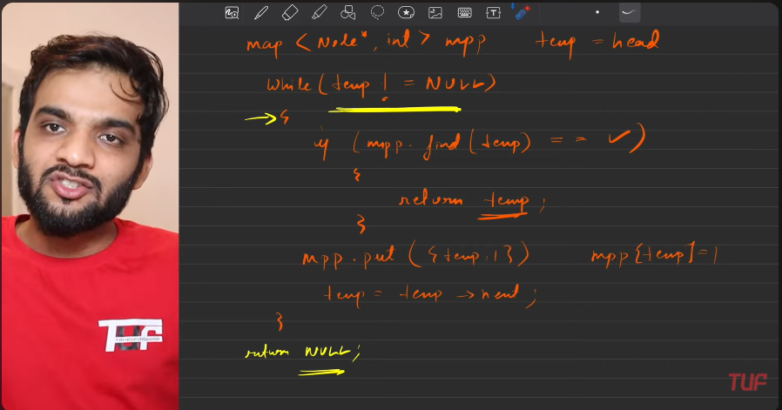
2. **Starting of cycle,Turtle-hoare**
   1. 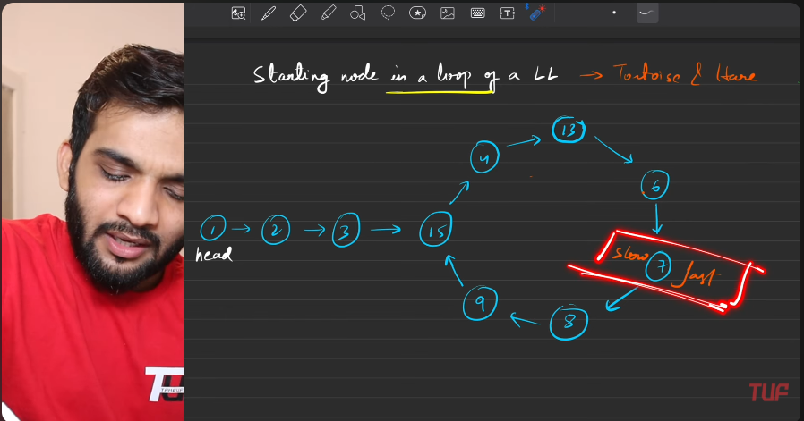
   2. 
   3. 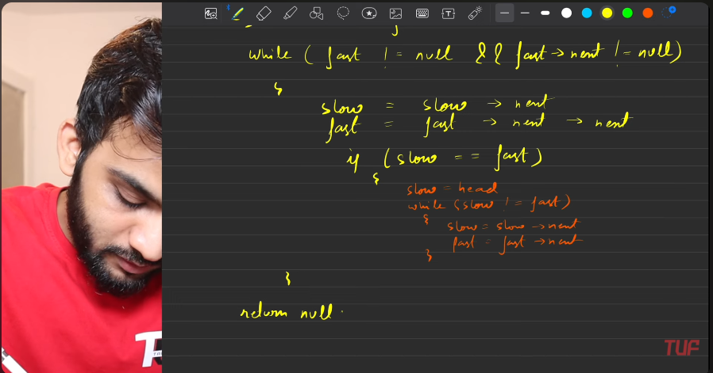
   4. 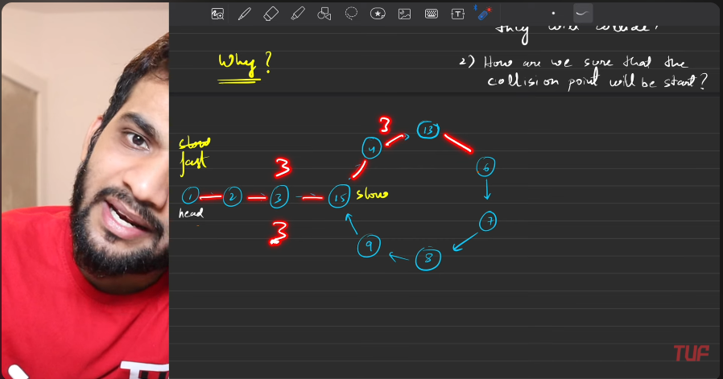
   5. 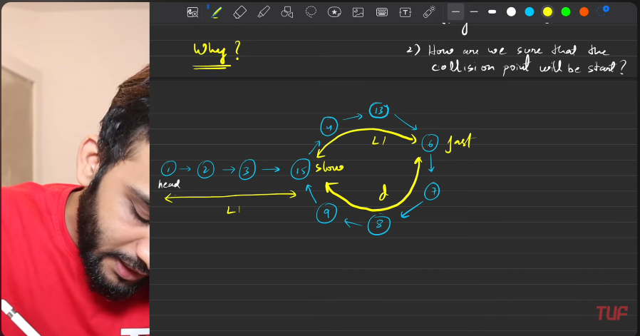
   6. 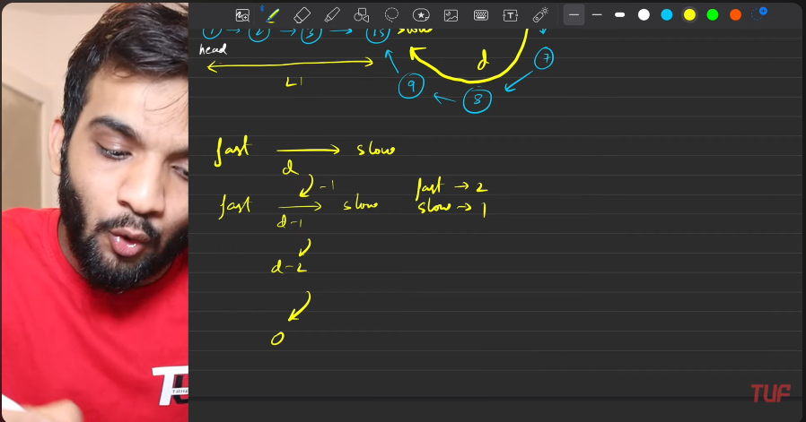
   7. 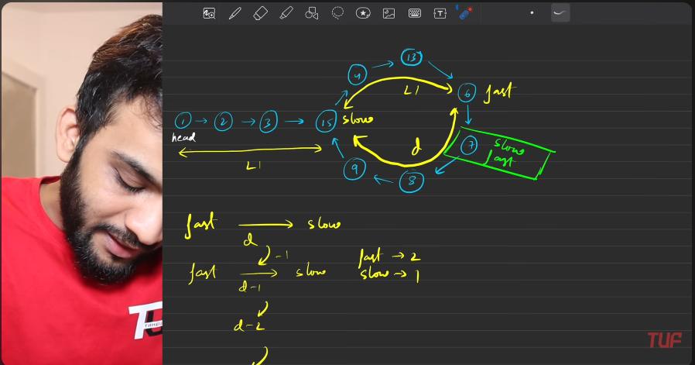
      1. When slow is moving L1 distance, the fast last has moved 2L1 diatnce, so the difference between the slow and fast is L1. 2L1 - L1 = L1. Considering that Slow is at the start of the cycle.
      2. The cycle must have some distance / loop has some distance. Let that be m. Hence M can be given like:
         1. M = L1+d, now considered d(assume) as the part of cycle.
         2. The d is the distance between the fast and slow too.
         3. Inevery iteration the distance between the fast and slow gets decreased by 1. Moving from fast to slow.
         4. So they meet when the distance between the fast and slow becomes equal to 0. The slow has moved for distance d.
         5. So, in the cycle, The slow has moved distance d. In Loop, How much left, is L1. Which is nothing but the starting from the start of the cycle.
   8. 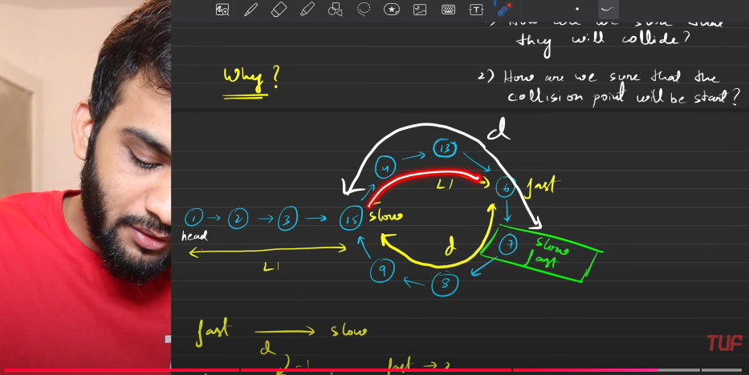
   9. 

**Length of The LOOP in the LL**

1. Hash
   1. Any particular node to be revisited, remembered.
   2. 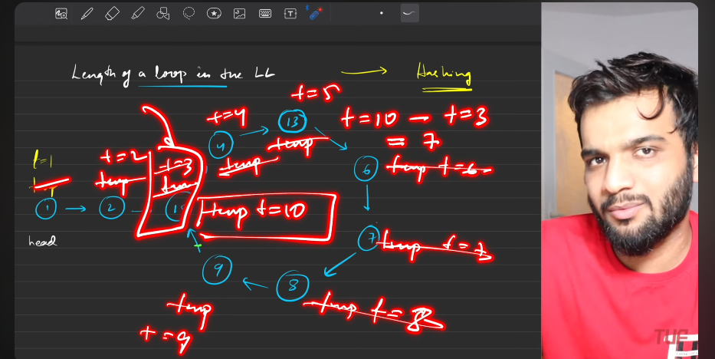
   3. The structure would be map<Node*, timer>, every time you move on keep increasing the timer. If the node is found again then subtract the current timings and th previous timings.
   4. 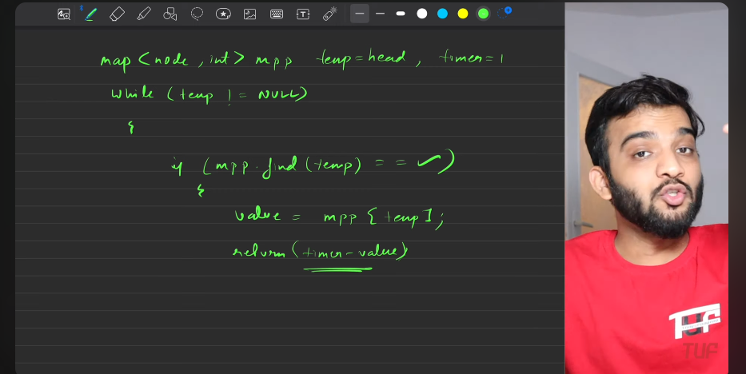
   5. 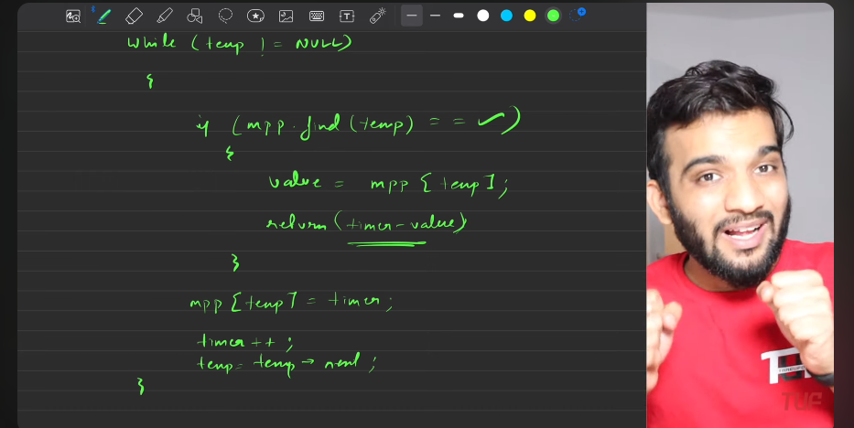
   6. 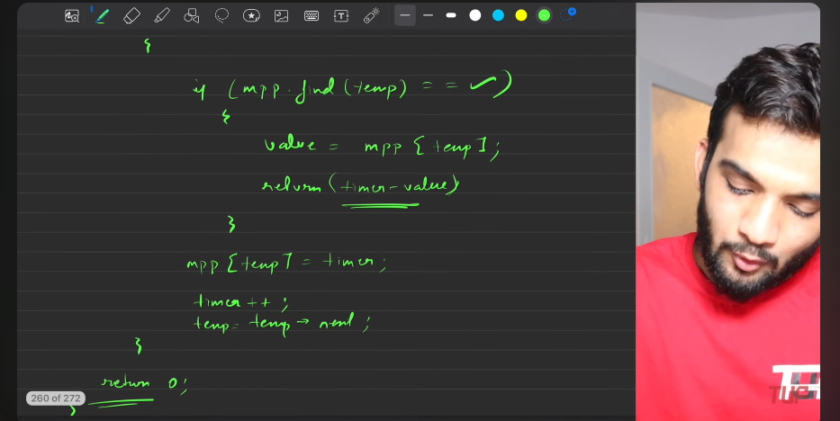
   7. 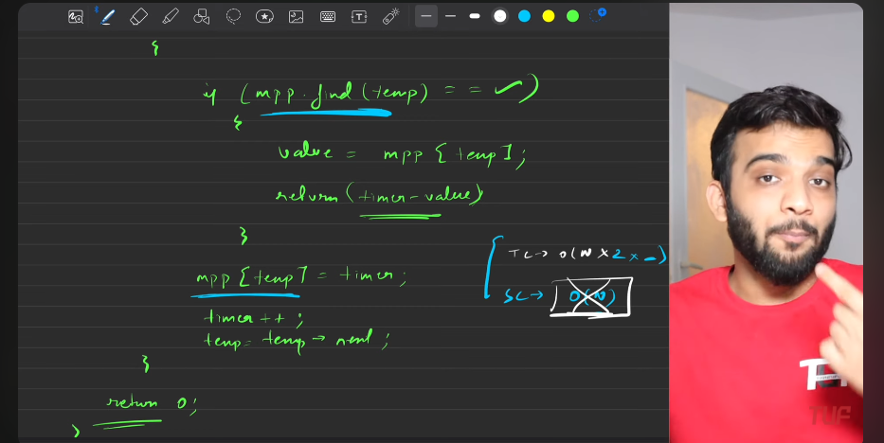
2. **Tortoise and Hoare**:
   1. First wait till the fast and slow converge
   2. Then start traversing the cycle. Till the fast and converge will meet. Till then increase the counter.
   3. 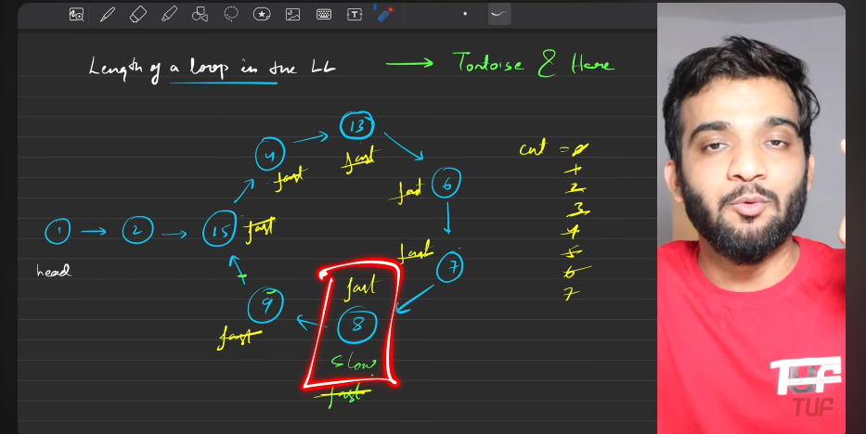
   4. return the length of count.
   5. 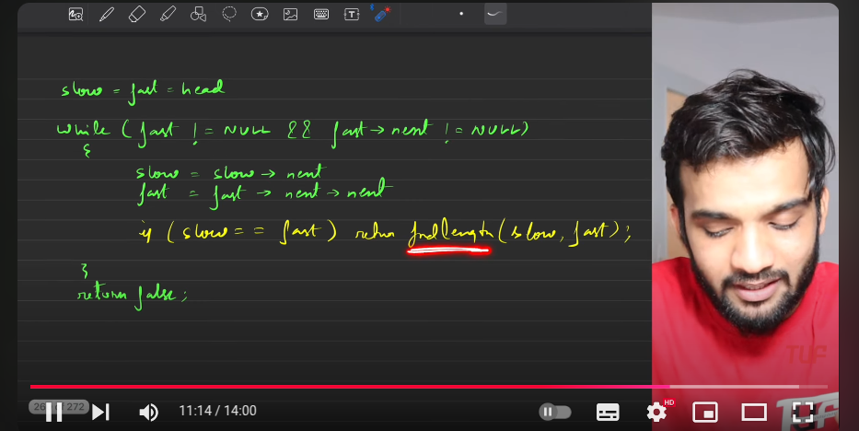
   6. 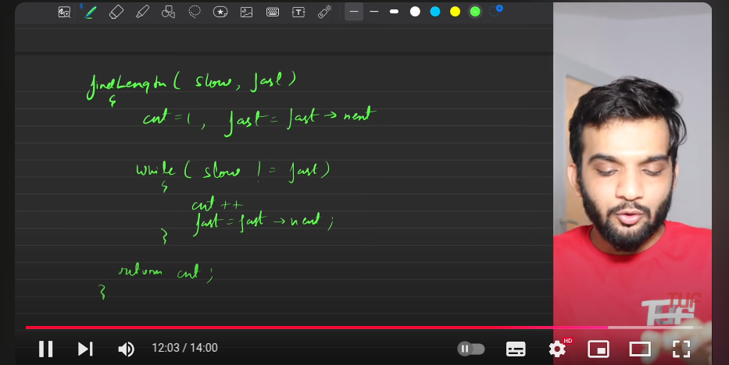
   7. 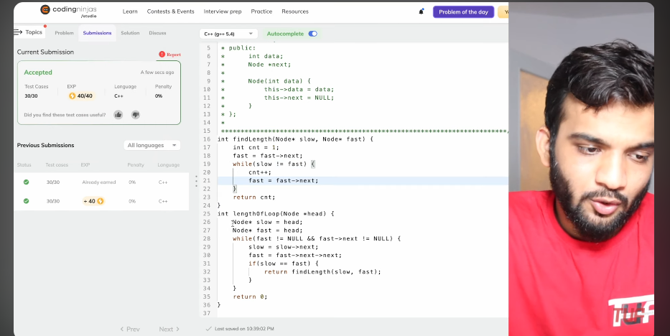

**Linked List is Palindrone or not**

1. 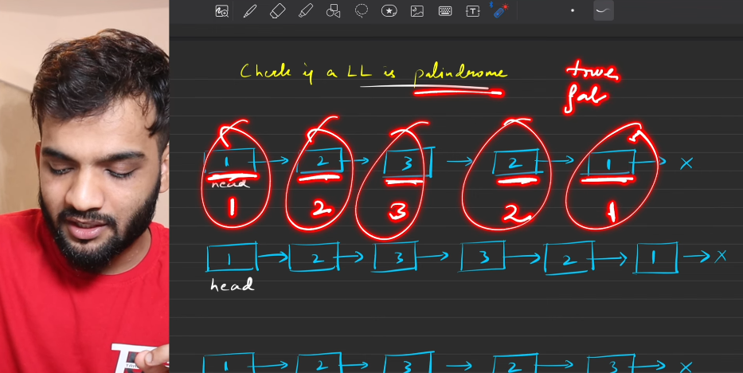
2. 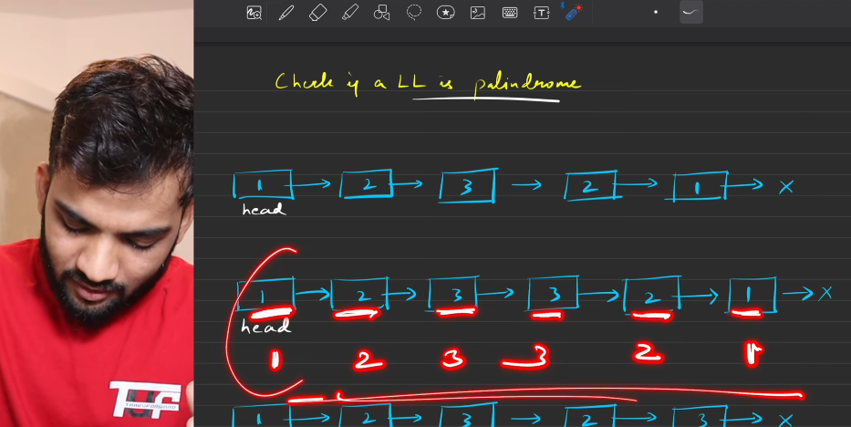
3. 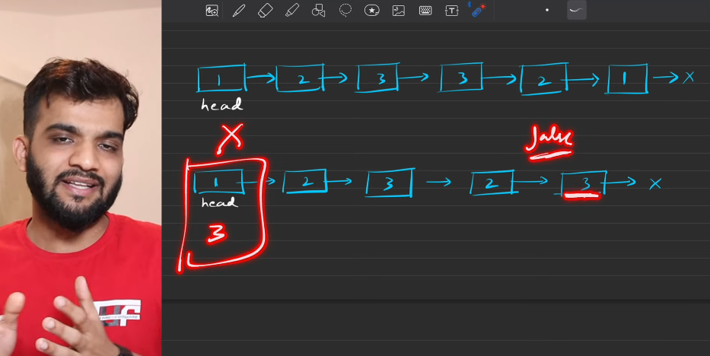
4. Stack:
   1. 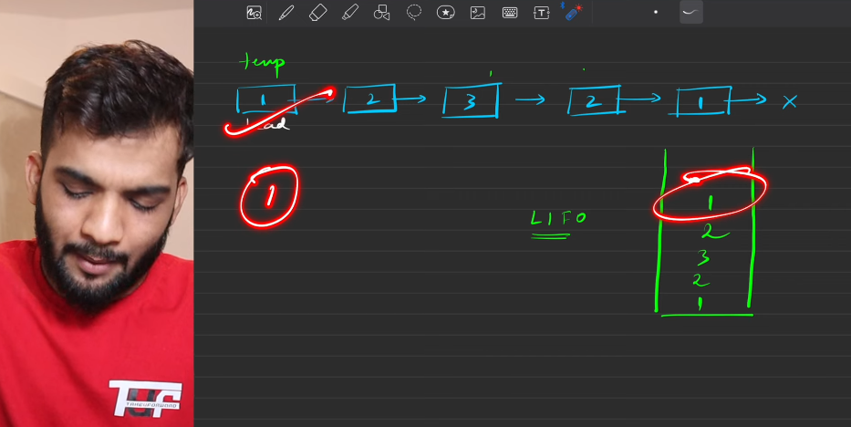
   2. 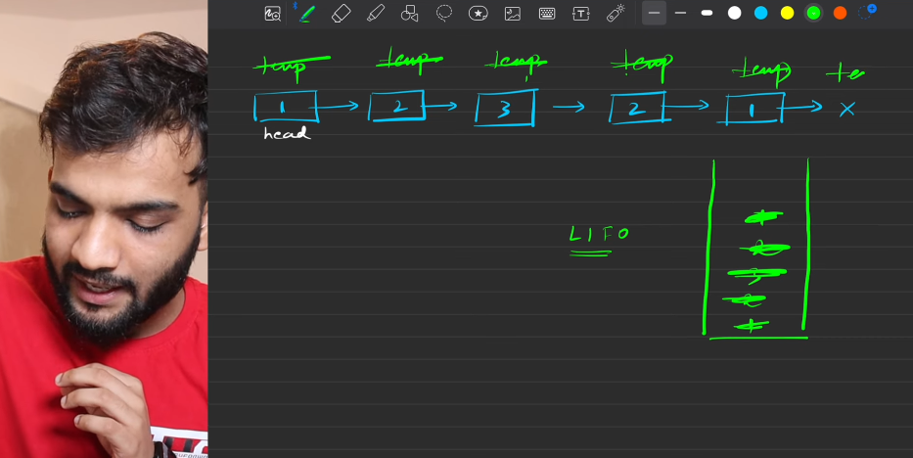
   3. 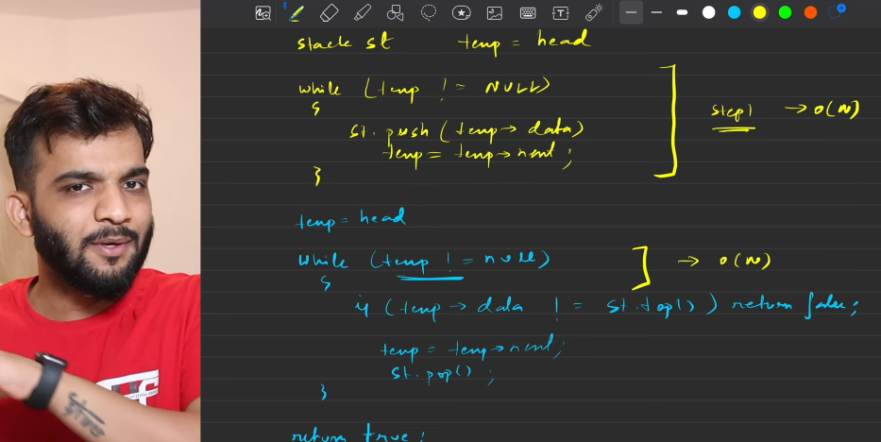
   4. 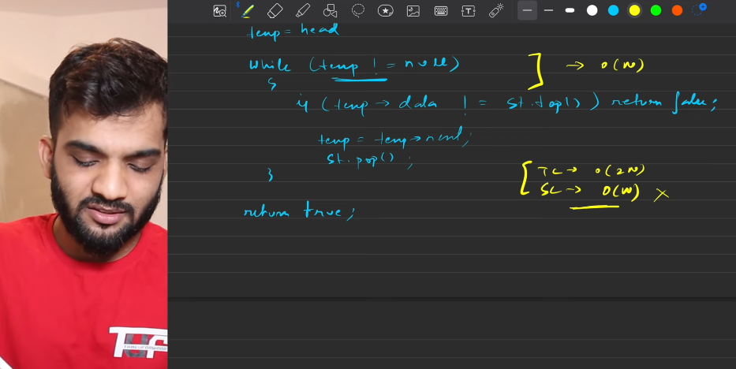
5. Linked list
   1. 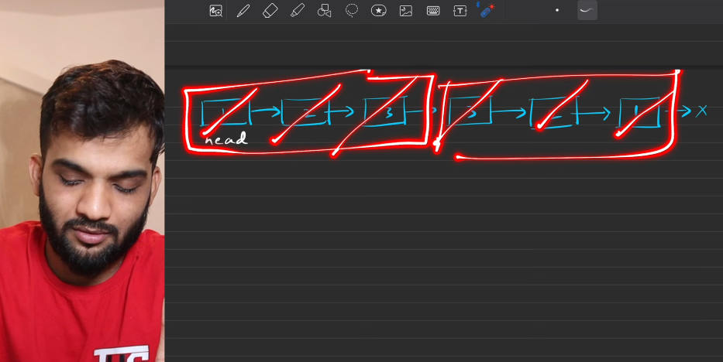
   2. 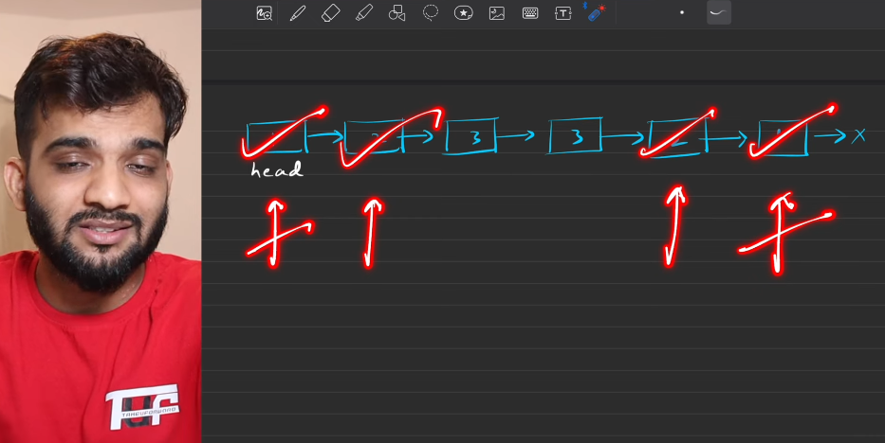
   3. Problem starts when you want to traverse in back from the end node.
   4. 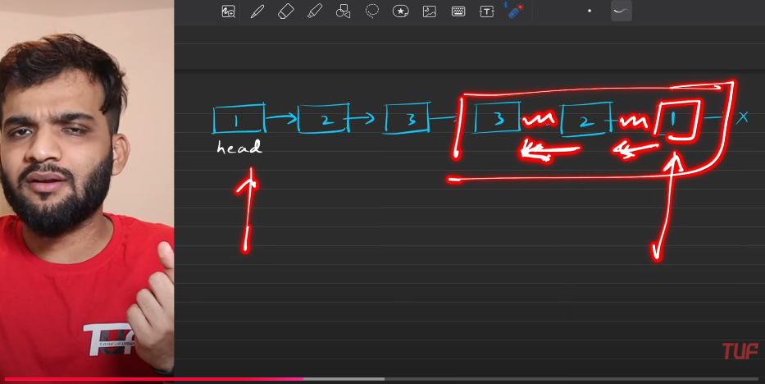
   5. This starts with recognising the second half.
   6. 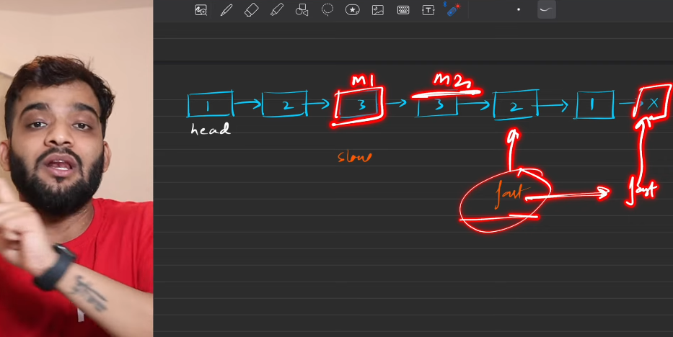
   7. We need to reach the first middle, so need a fast pointer making it to reach the last 2nd node.
   8. 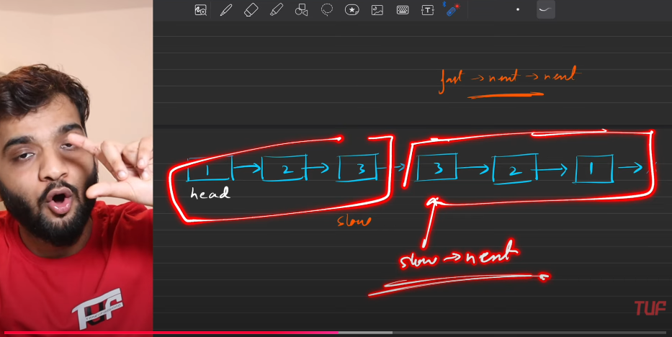
   9. 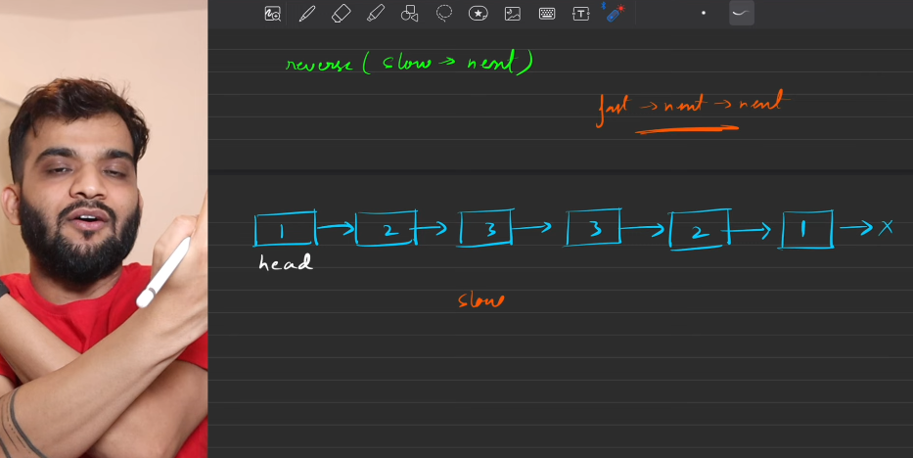
   10. 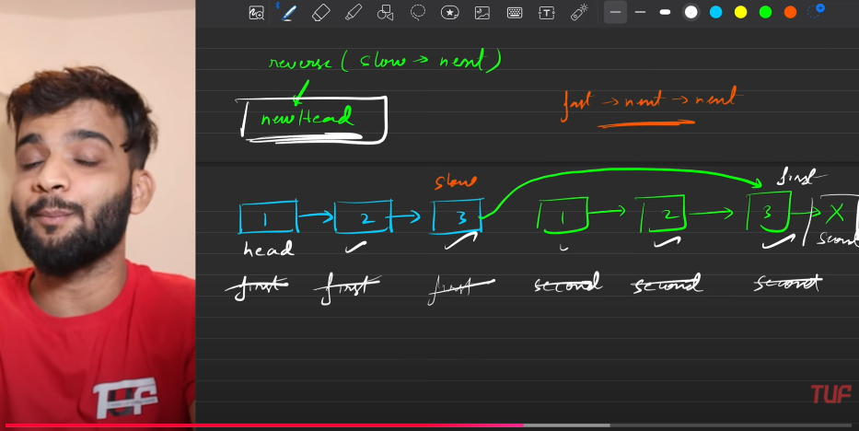
   11. 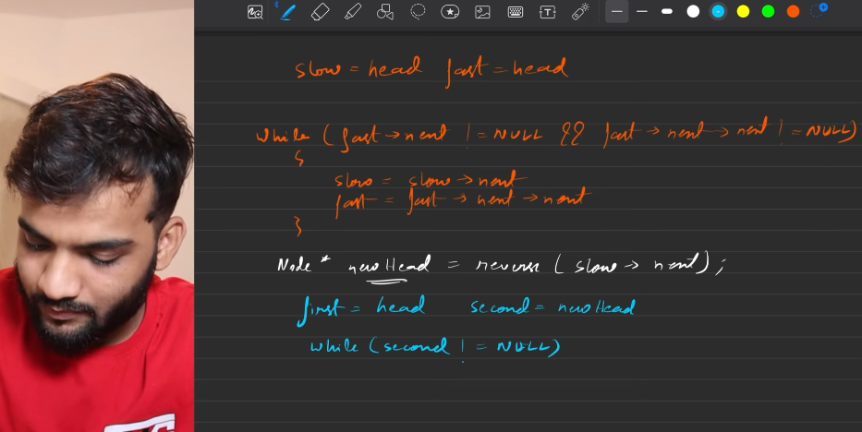
   12. 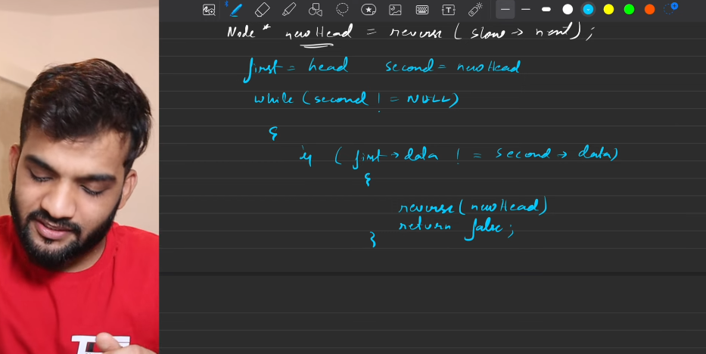
   13. 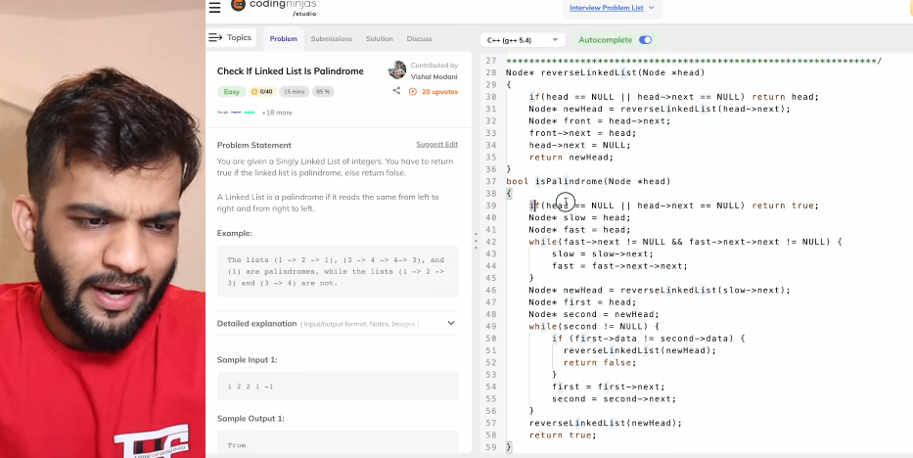

**ODD INDEX NODE THEN EVEN INDEX NODE**

1. 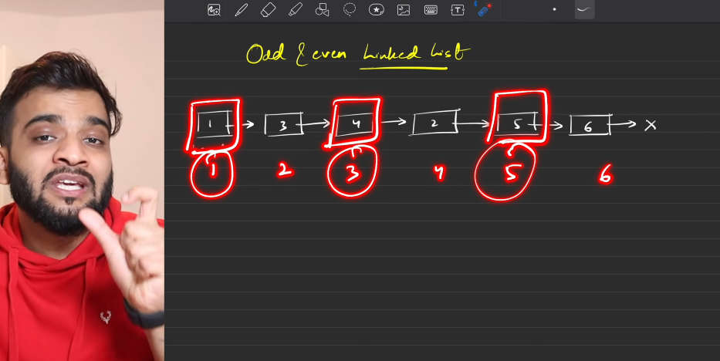
2. 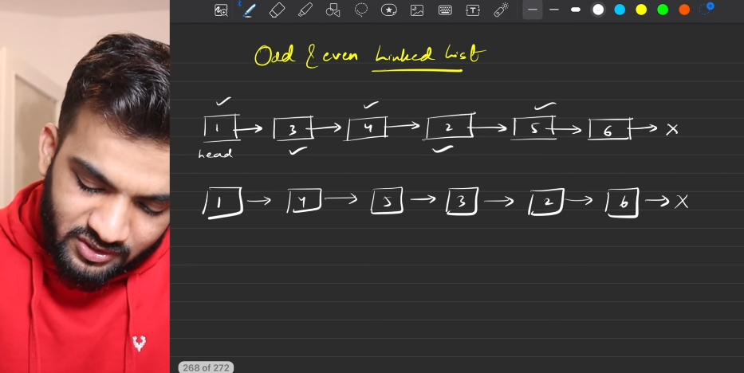
3. **Bruteforce**
   1. 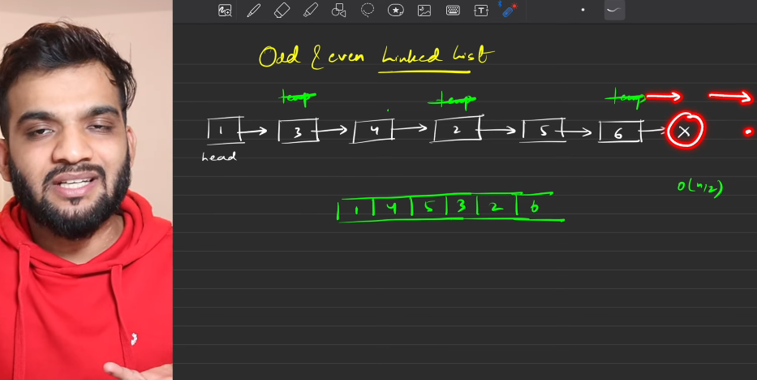
   2. Stop when you reach the last node.
   3. 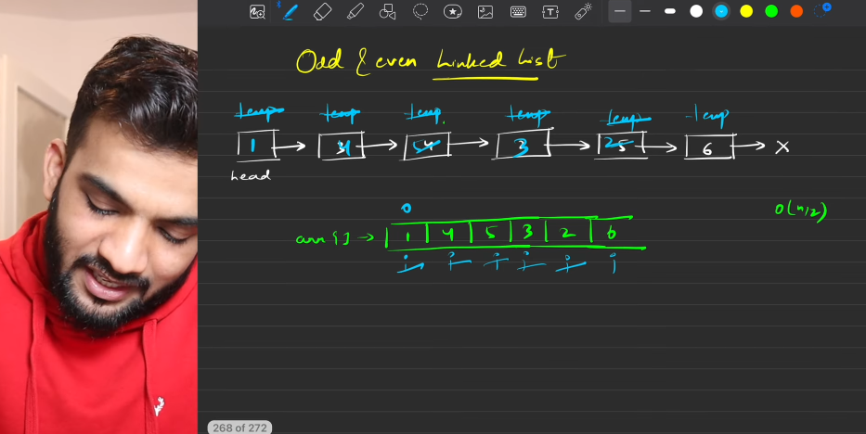
   4. 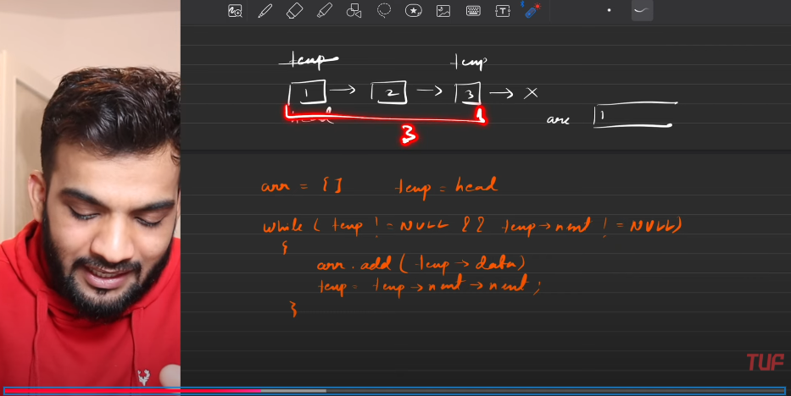
   5. 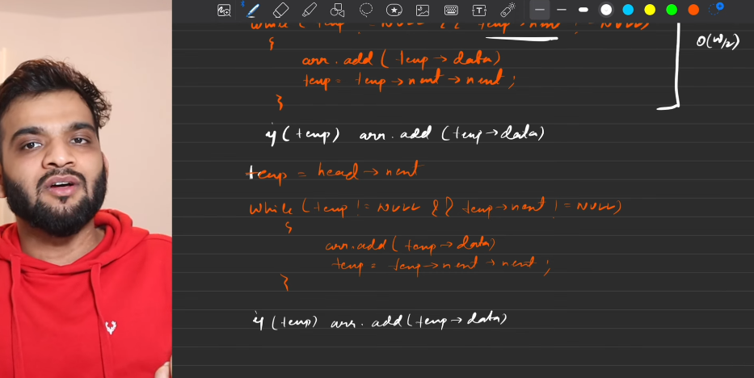
   6. 
4. WITHOUT USING ANY EXTERNAL DATASTRUCTURE
   1. 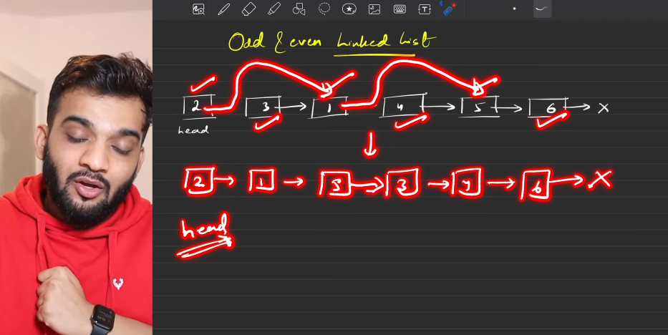
   2. Dealing with odd
   3. 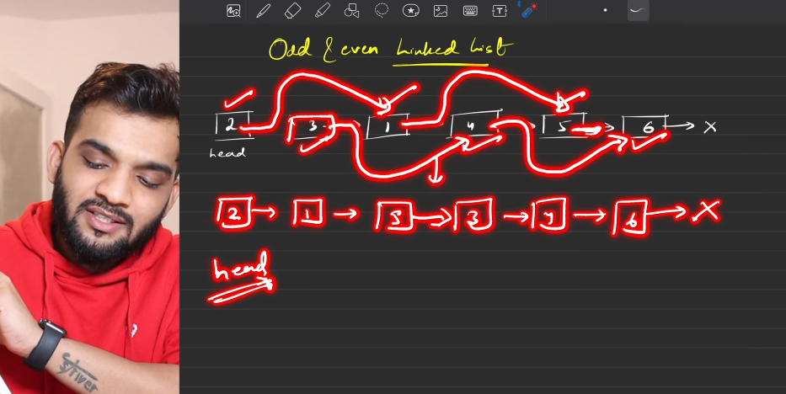
   4. Dealing with even index node.
   5. 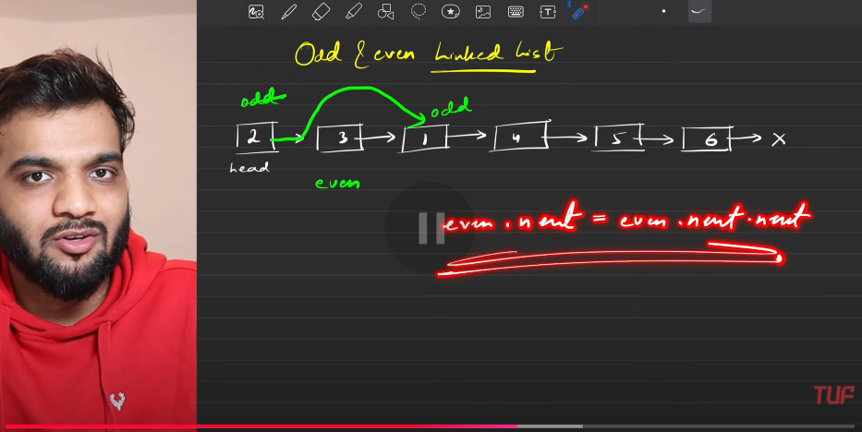
   6. 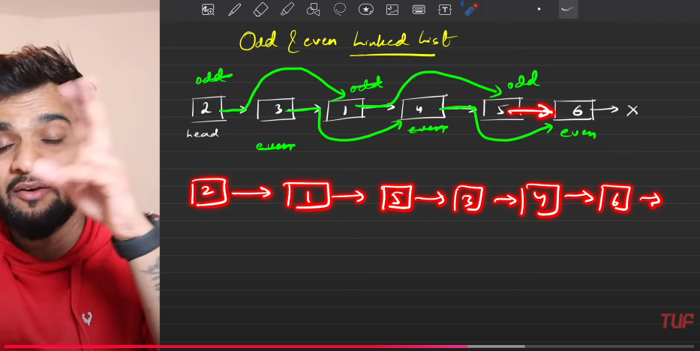
   7. 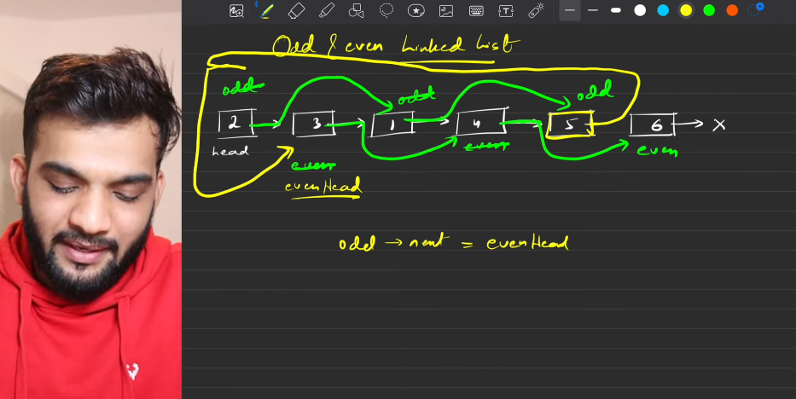
   8. 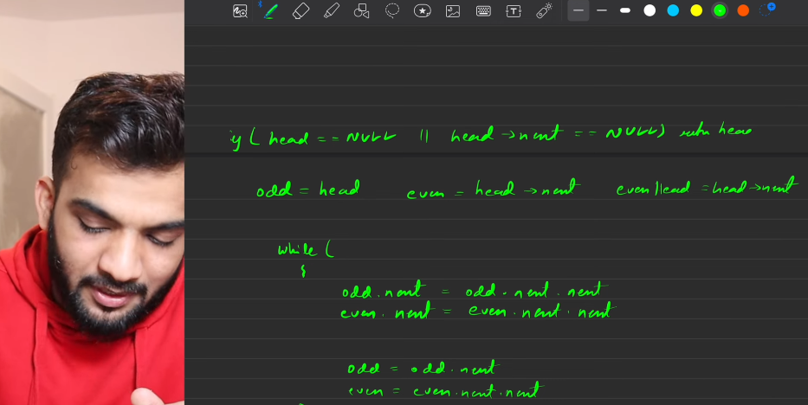
   9. 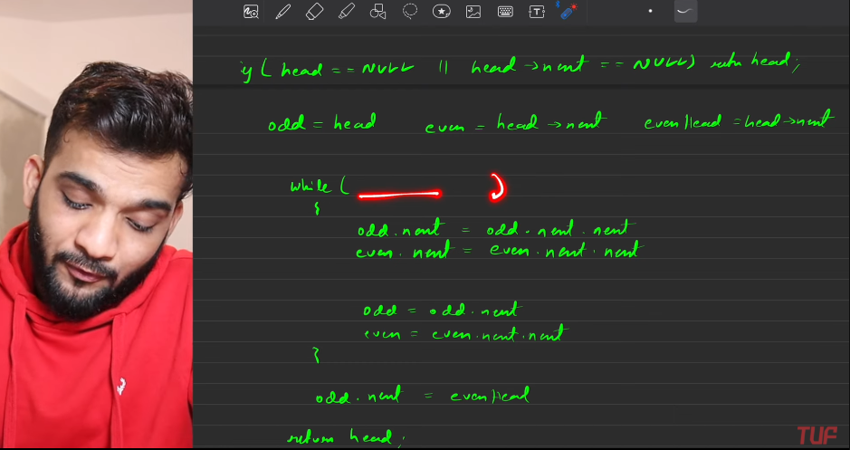
   10. 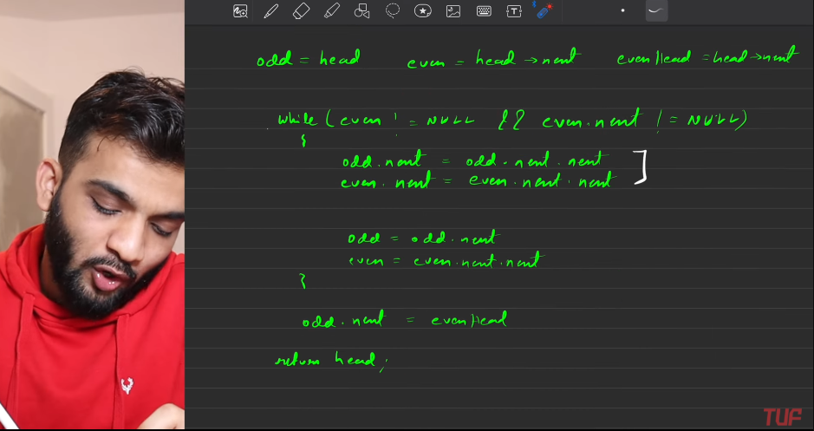
   11. 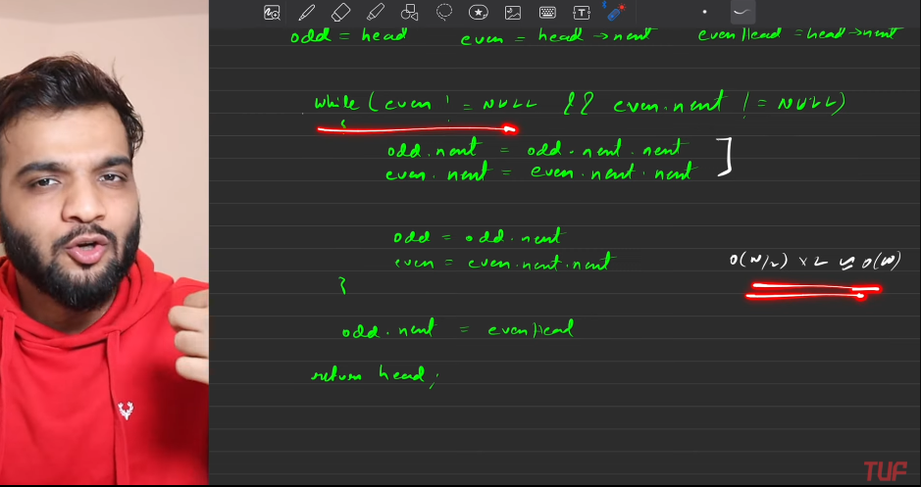
   12. 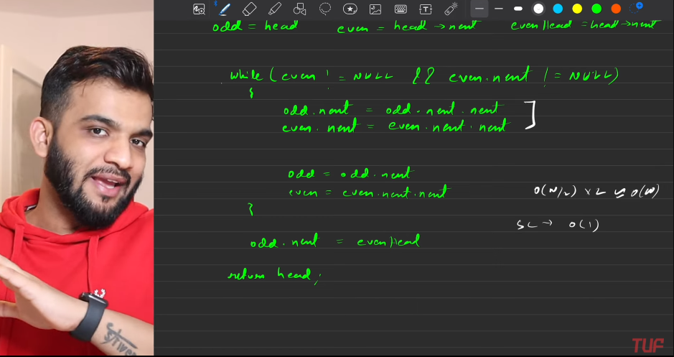
   13. Even is in frot of odd, so keeping track of even will genearate the results.

**REMOVE THE NTH NODE FROM THE END OF LINKED LIST**

1. Brute force:
   1. By count first, based on that another tarversals to remove that node.
   2. 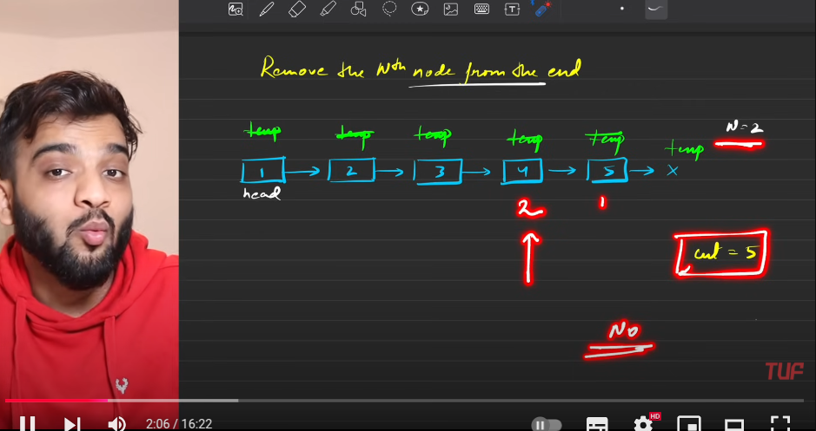
   3. 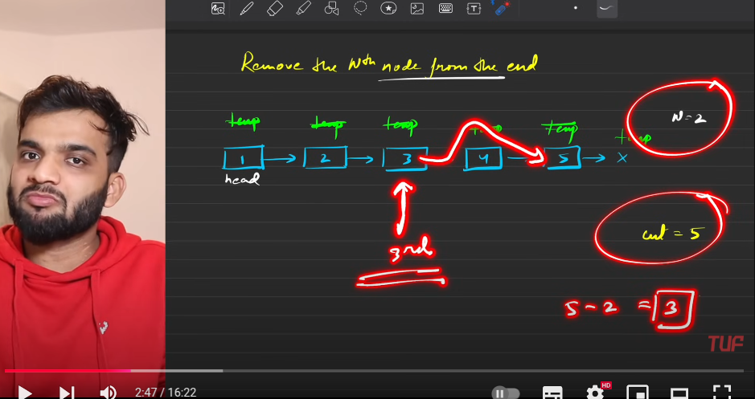
   4. 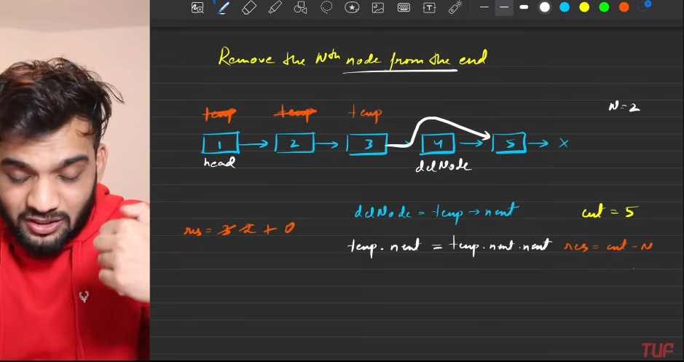
   5. 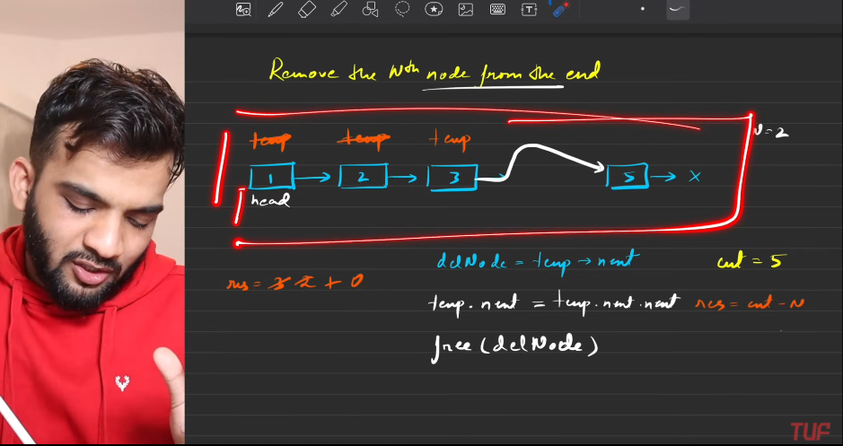
   6. 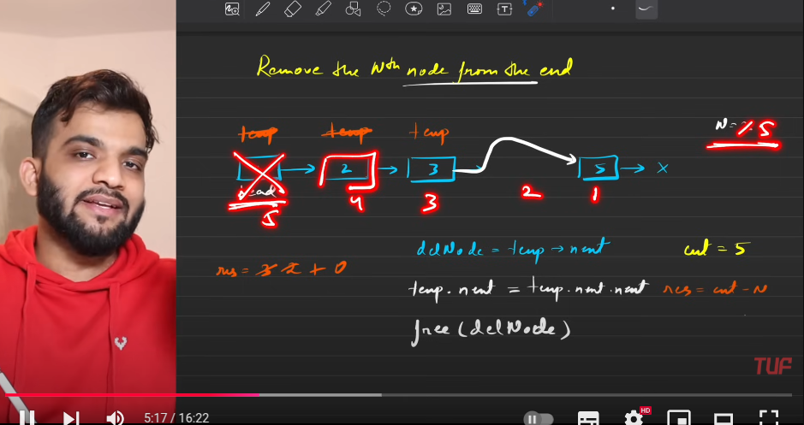
   7. 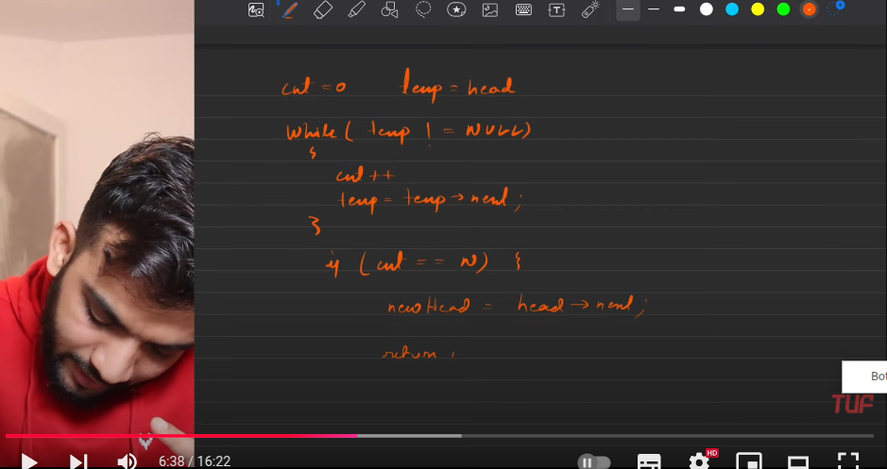
   8. 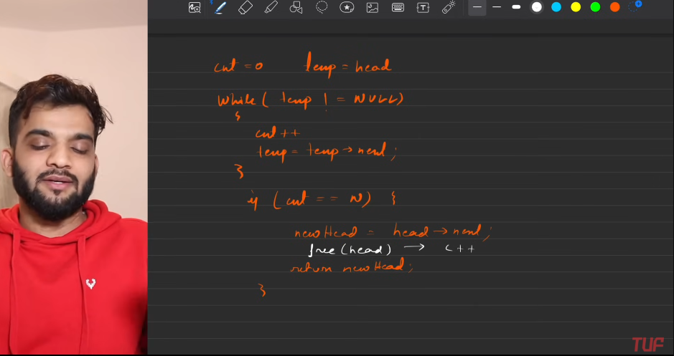
   9. 
   10. 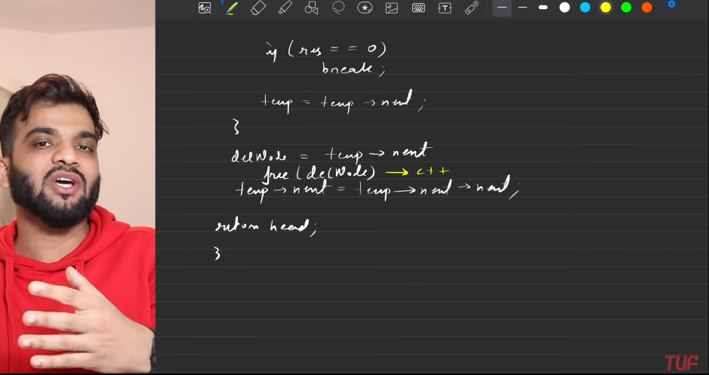
   11. 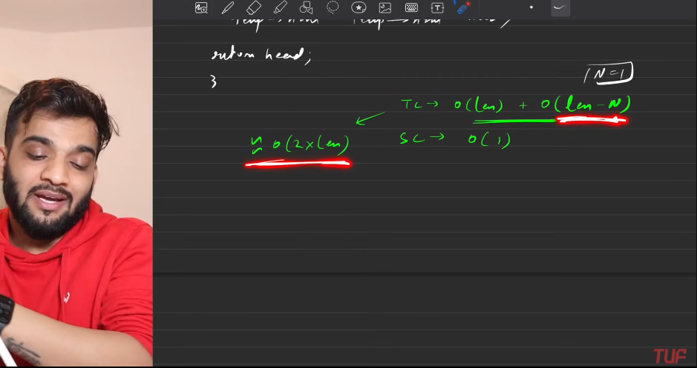
2. Optimised Result[FAST POINTER]:
   1. 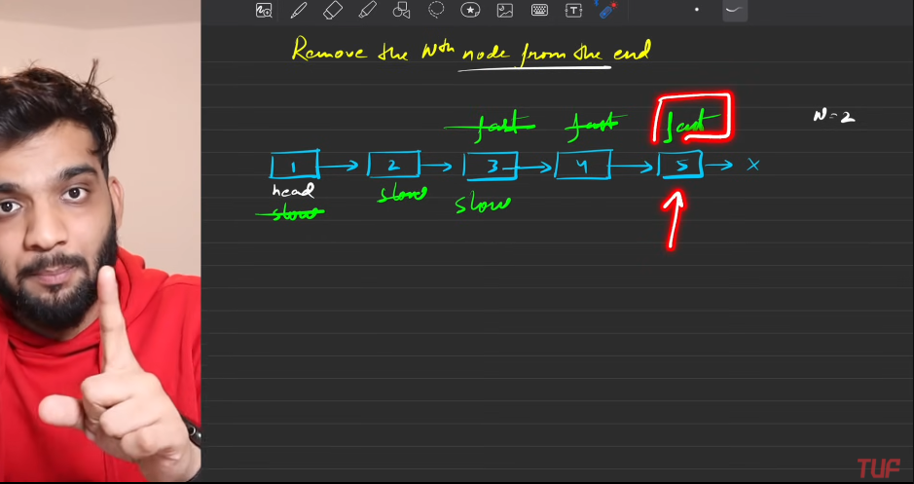
   2. 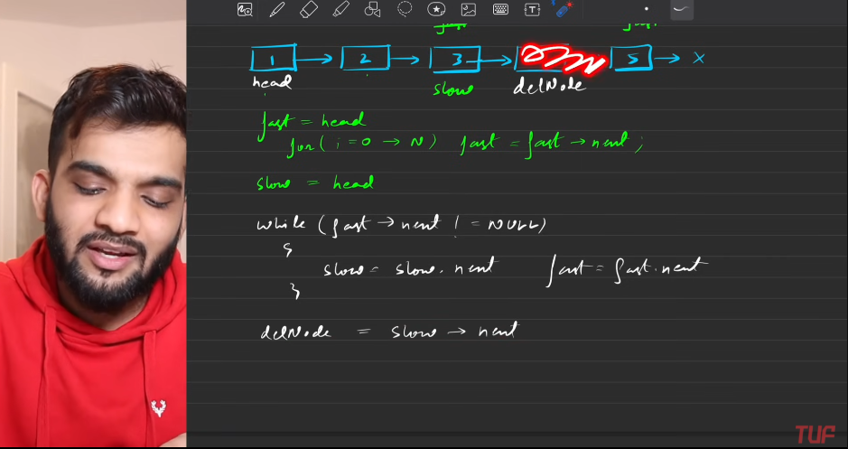
   3. 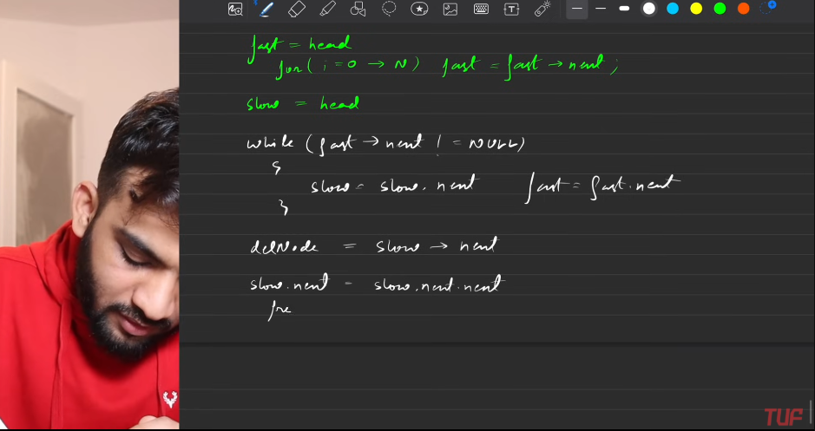
   4. 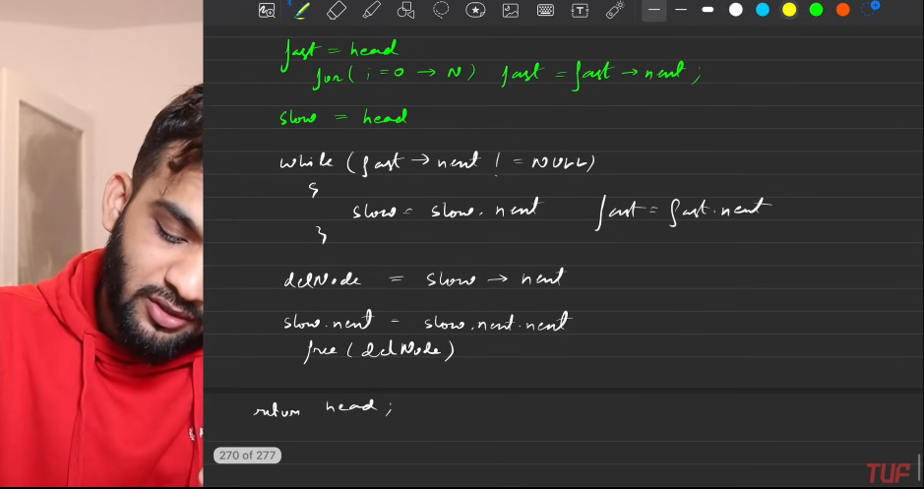
   5. 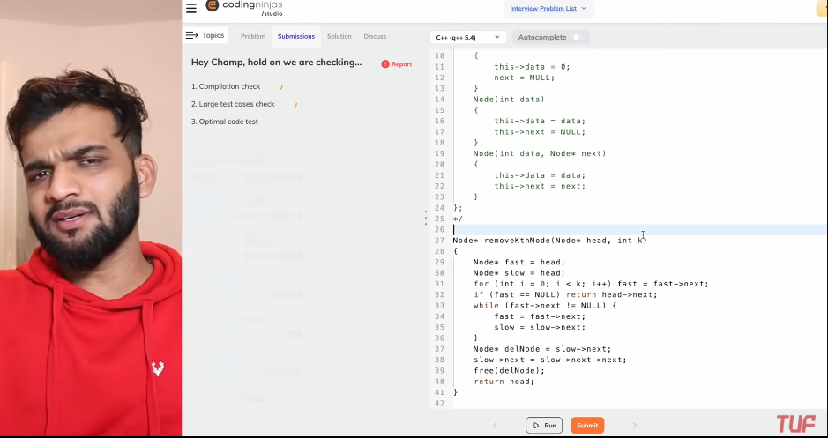

**DELETE THE MIDDLE NODE**

1. Odd

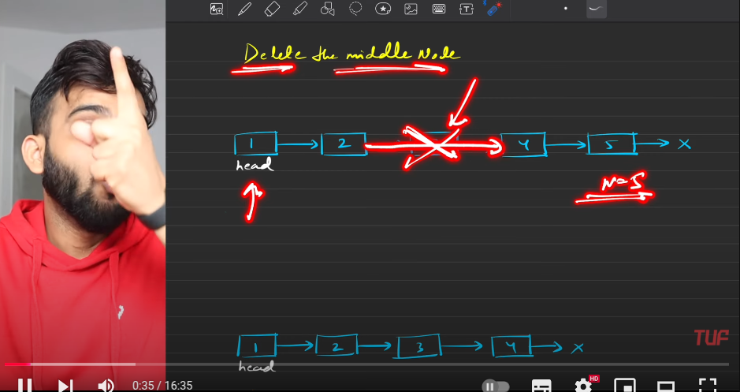

Even



1. Direct deletion of middle node will put me in useless situation, so need to reach the node which is just behind the middle node, so you can easily change the link.
   1. 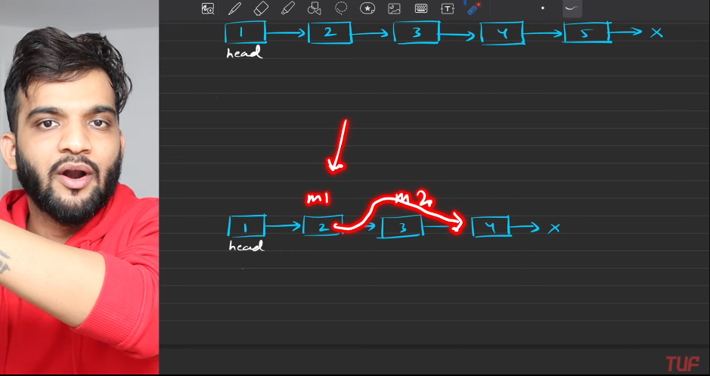
   2. 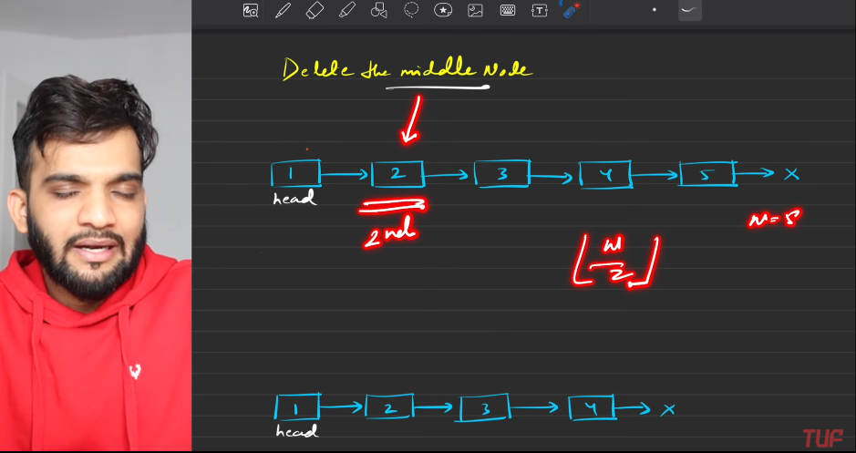
   3. 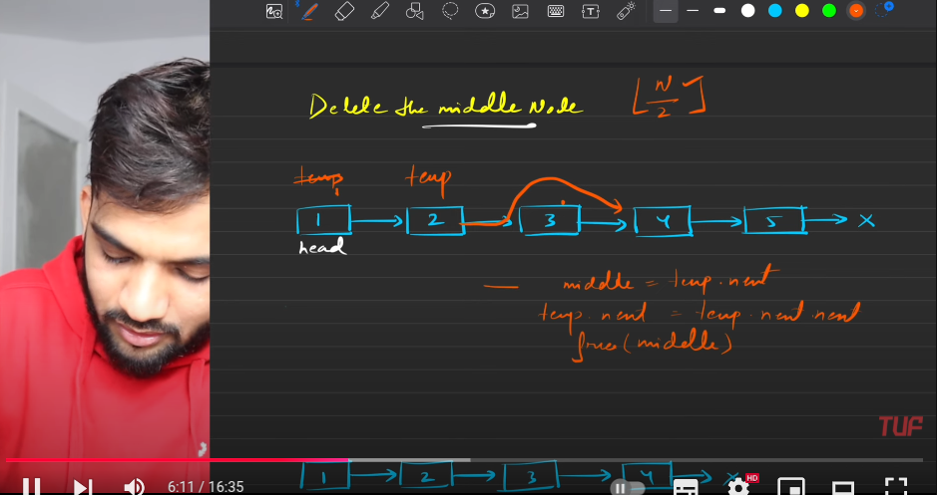
   4. 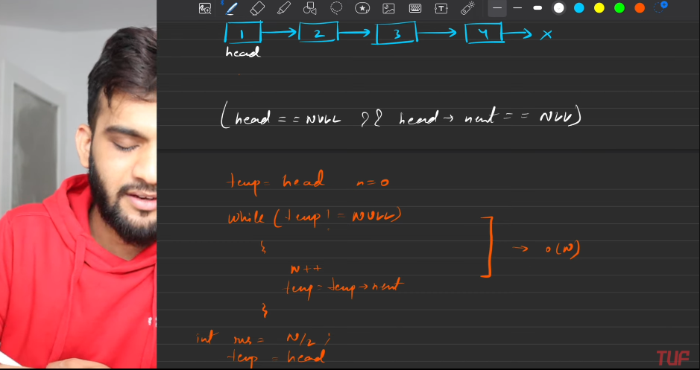
   5. 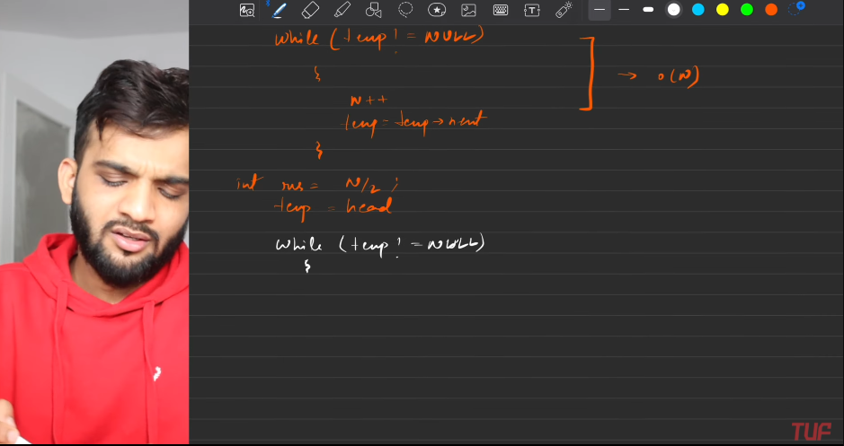
   6. 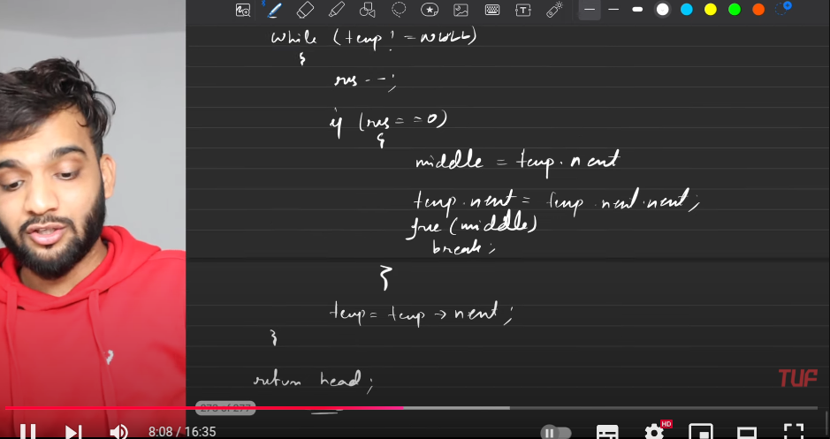
   7. 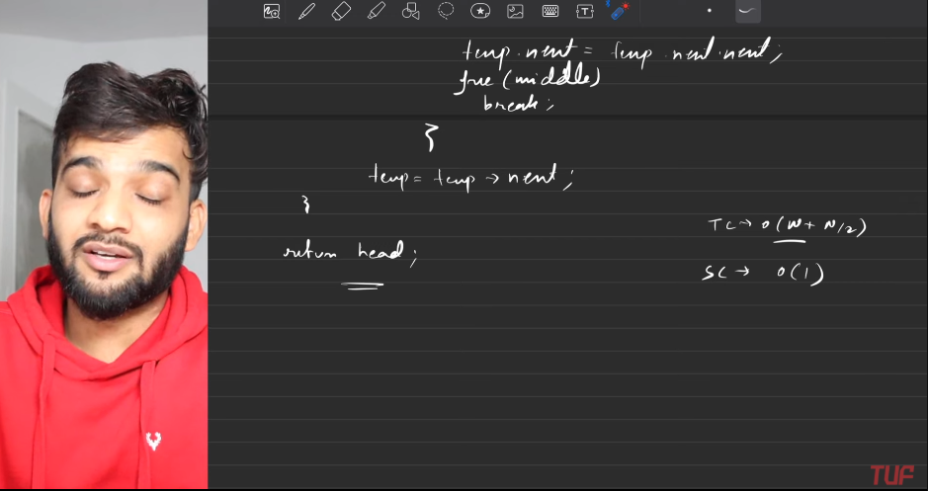
2. **Tortoise and Hoare**:
   1. In even length list, the pointer is used to point to the NULL.
   2. In odd length list, The pointer is used to meet node, whose next is NULL.
   3. Slow always at the middle, which needs to be deleted.
   4. We needed to reach the middle -1, so that I can remove the node easily. So **Skip one step of slow.**
   5. 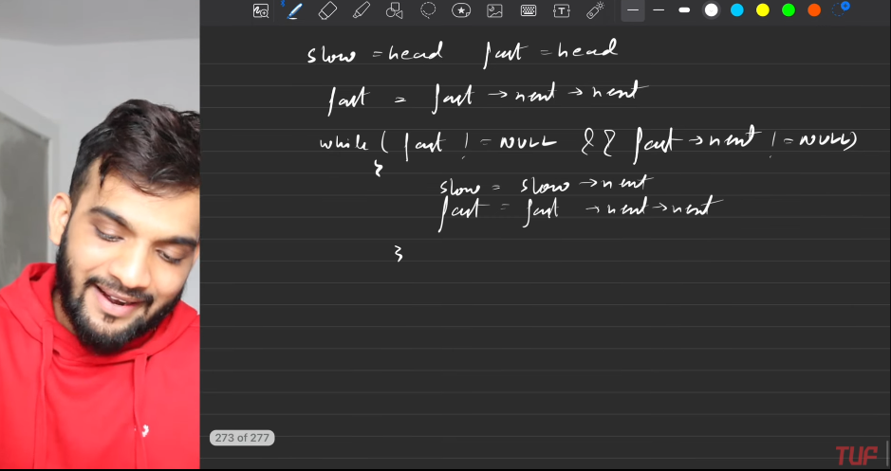
   6. 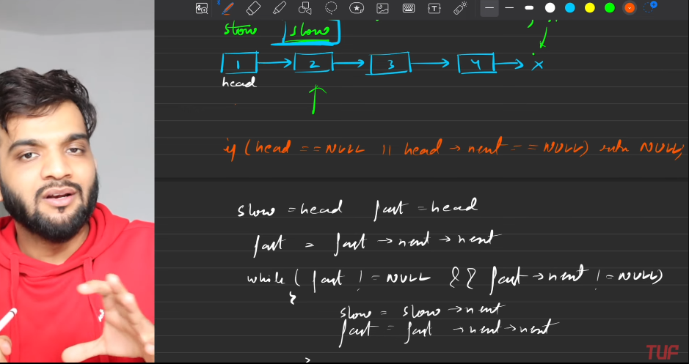
   7. 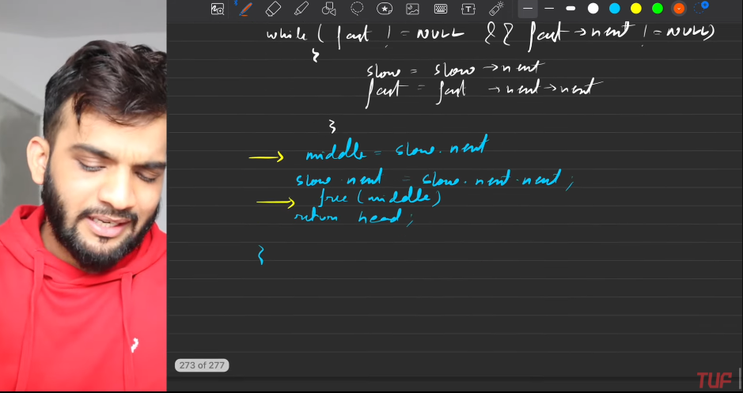
   8. 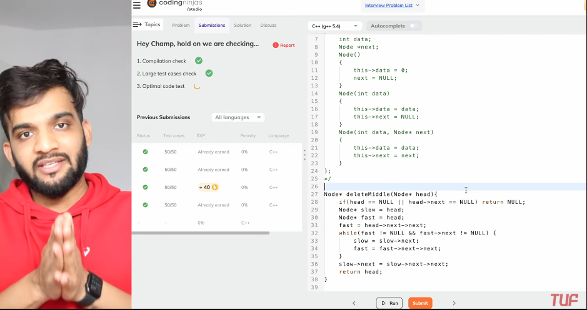

**SORT A LIST**

1. Bruteforce
   1. Use array , store the elements of linked list into array and sort and make the list by using above array.
   2. 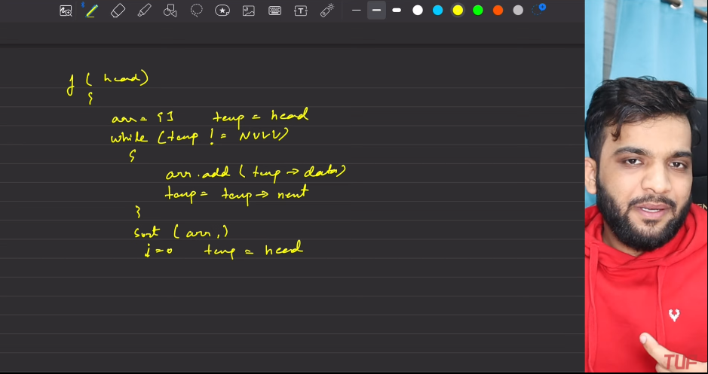
   3. 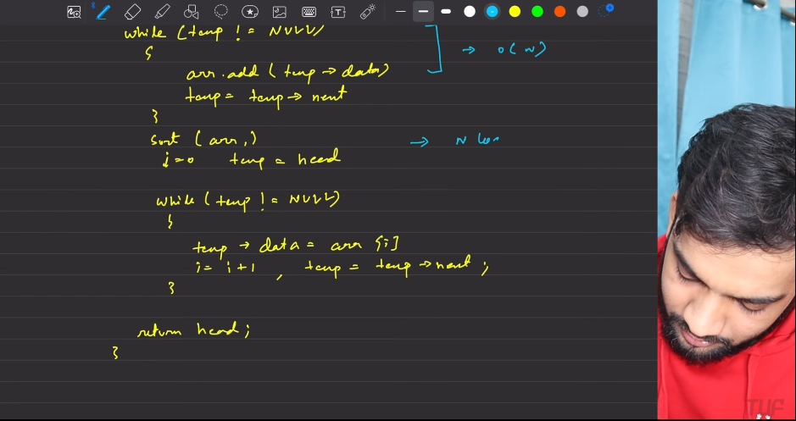
   4. 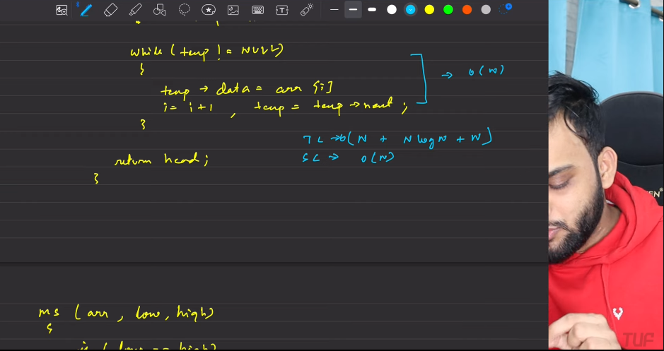
2. Merge-Sort
   1. 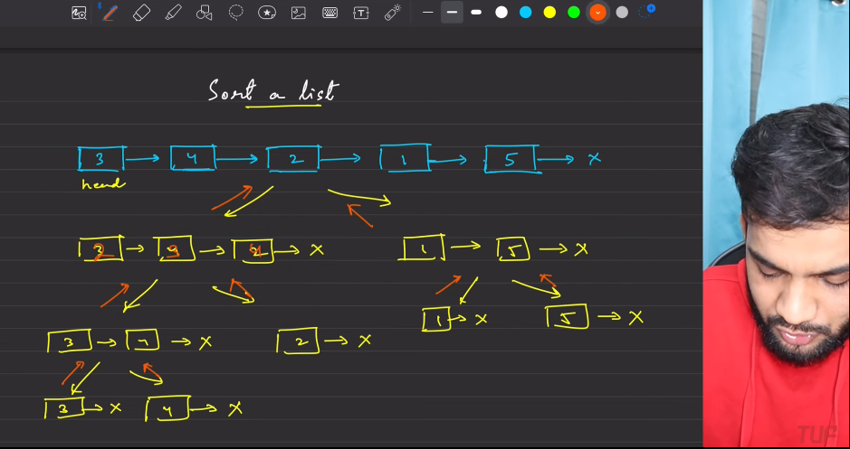
   2. 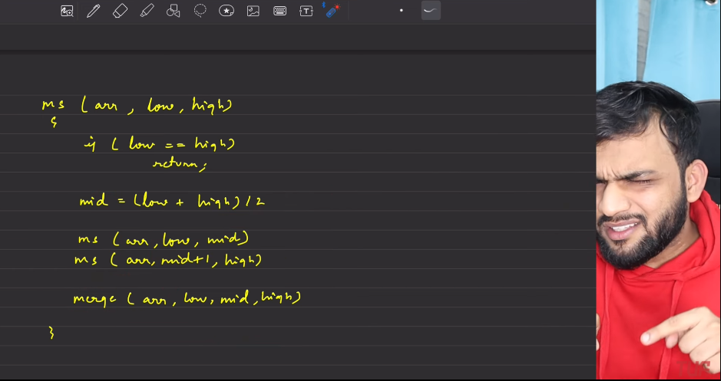
   3. 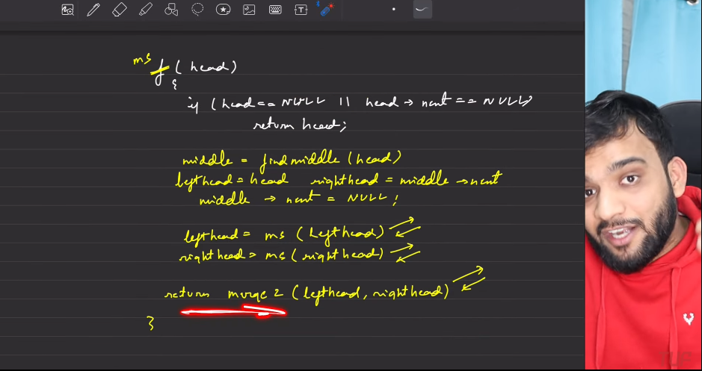
   4. 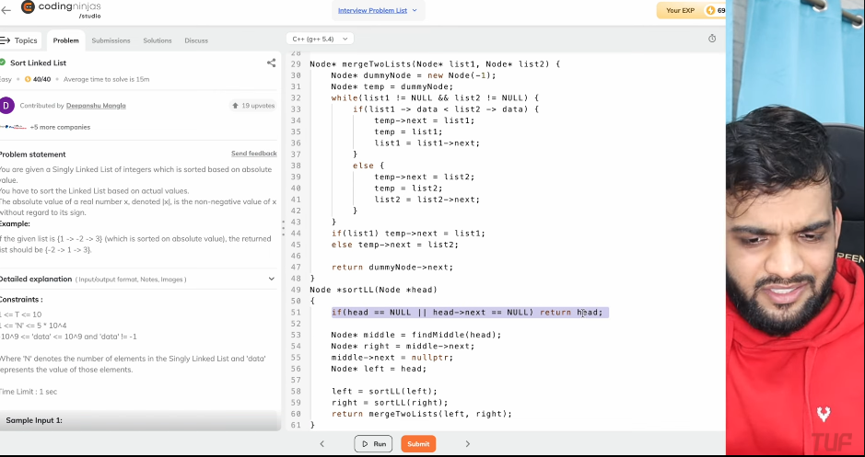
   5. 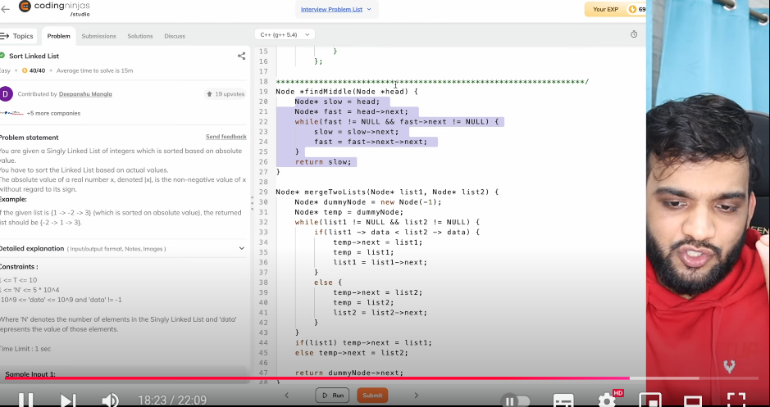
   6. 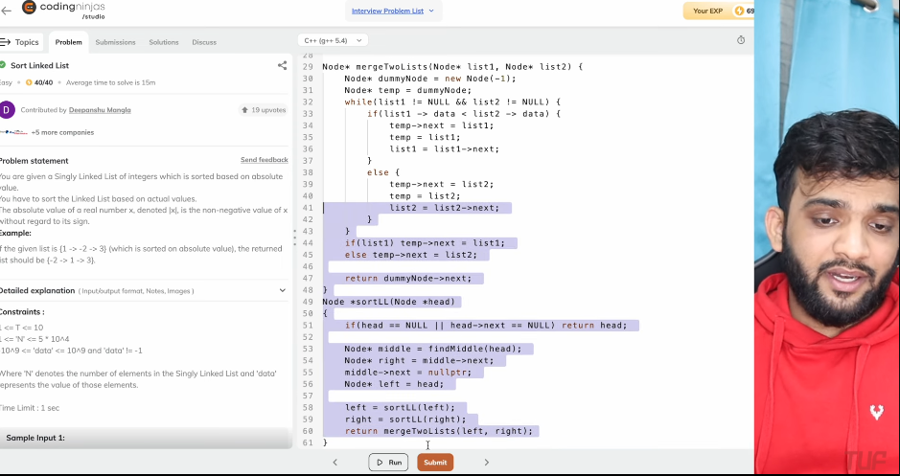
   7. 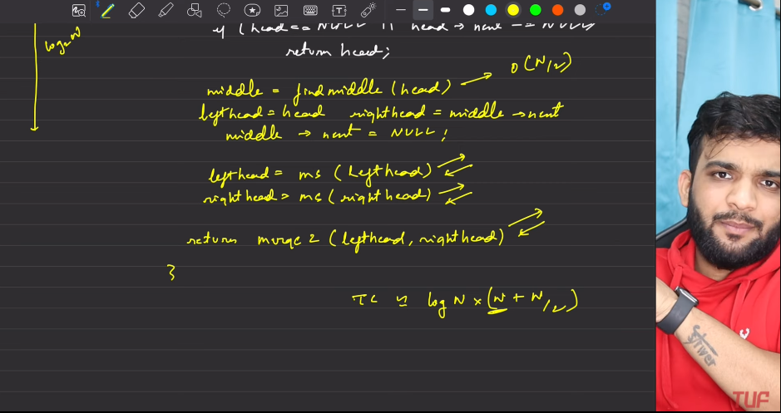

**SORT a LL of 0s 1s 2s**

1. Counters
   1. 0,1,2 variables which count for 0s, 1s, 2s in the Linked List anad based on that List is manipulated.
   2. When reaches the end of linked list or when 0 becomes zero, sequentially.
   3. 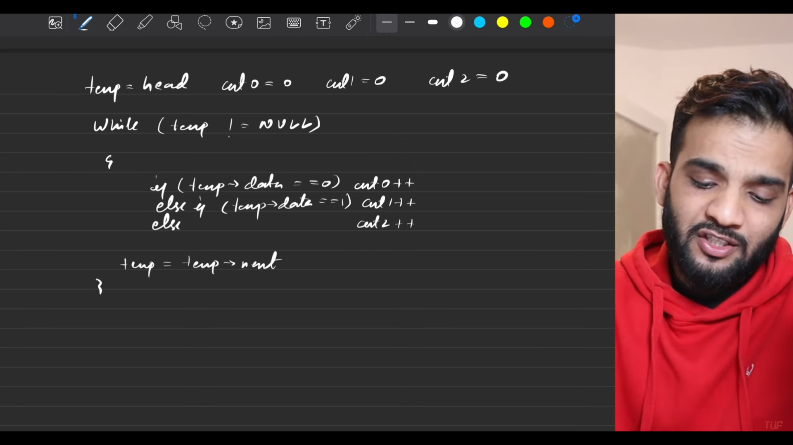
   4. 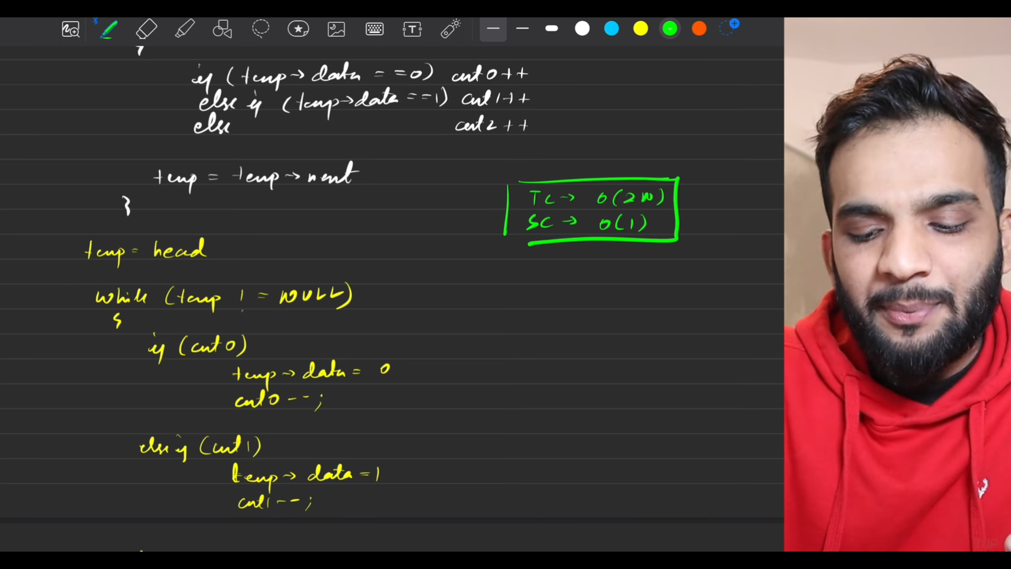
   5. 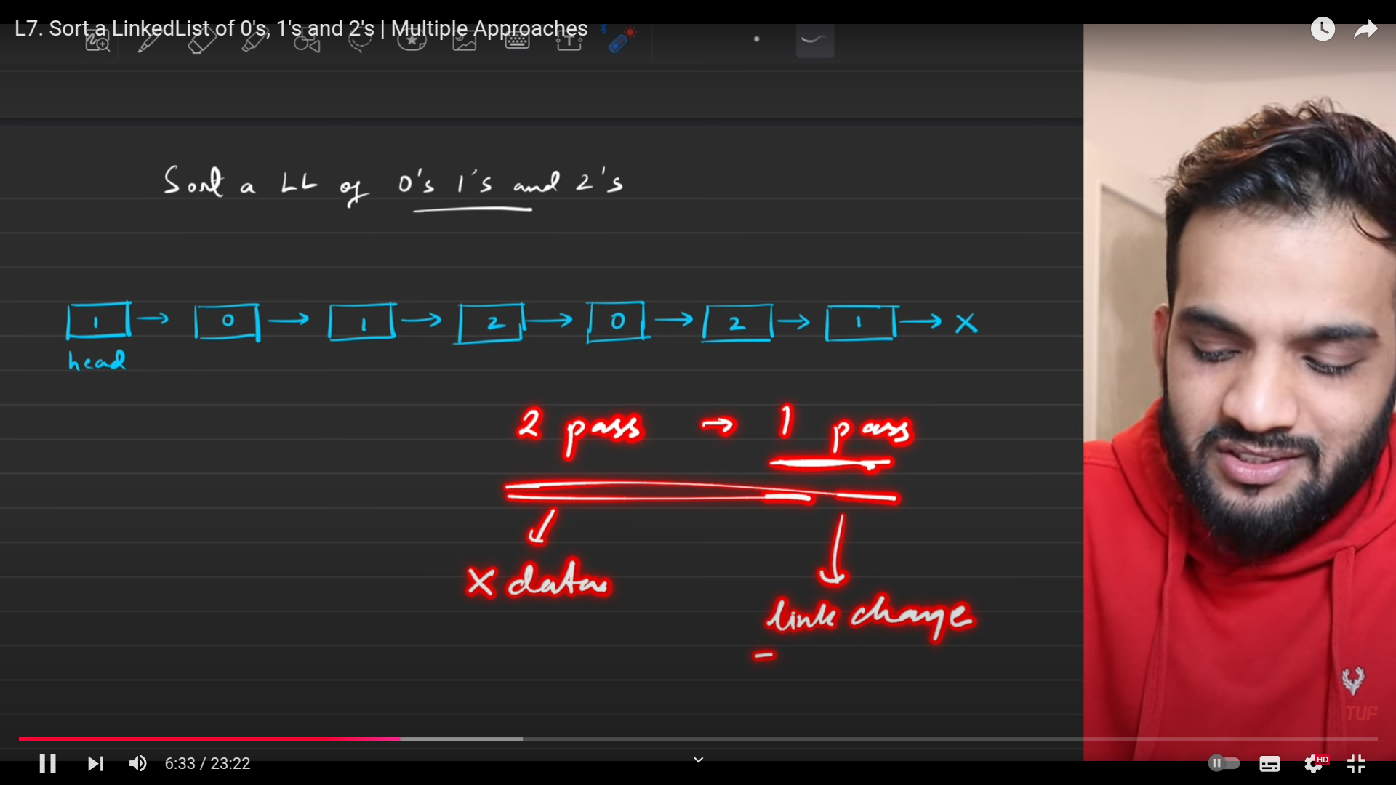
   6. 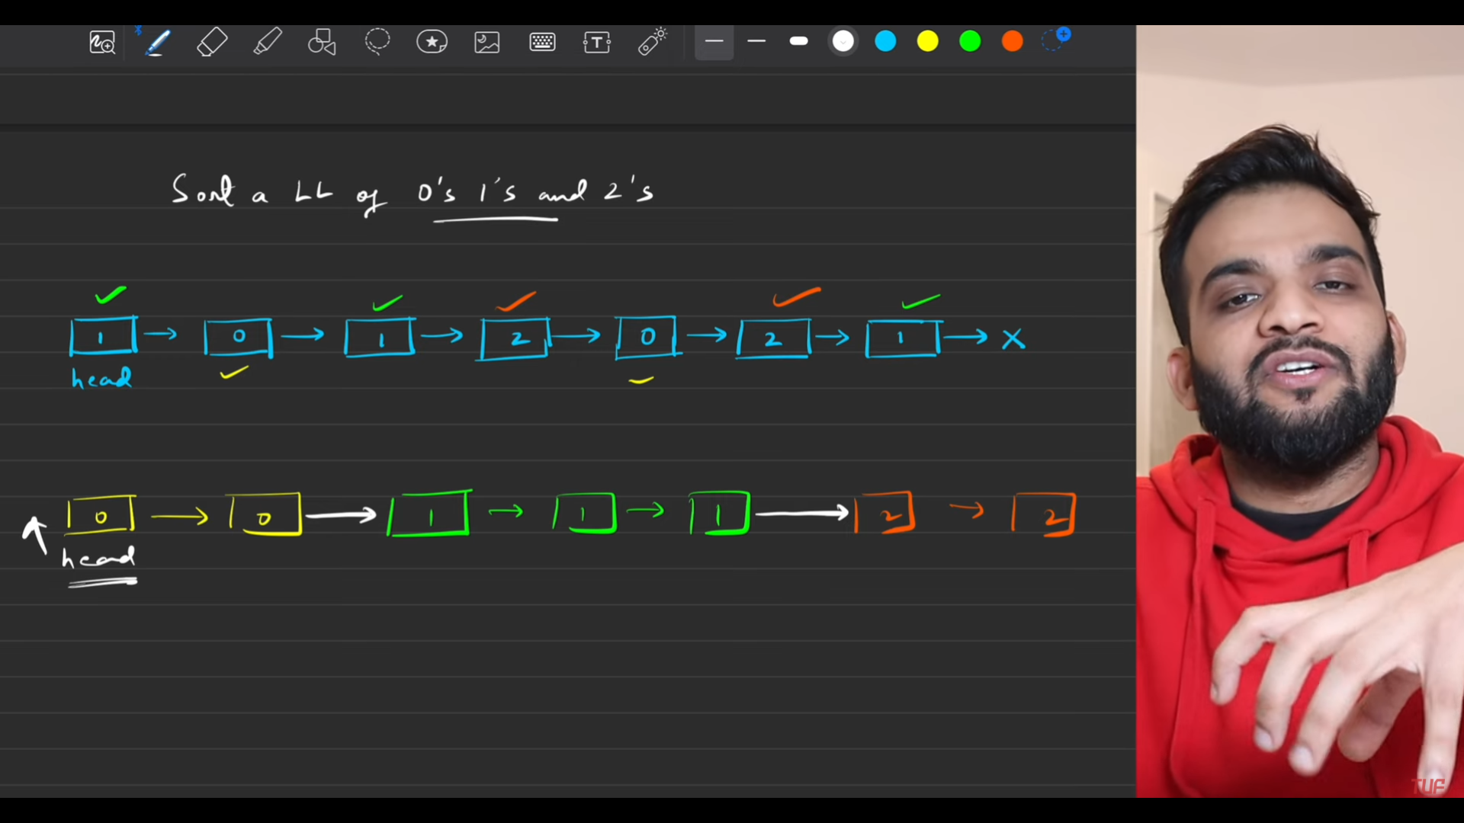
   7. 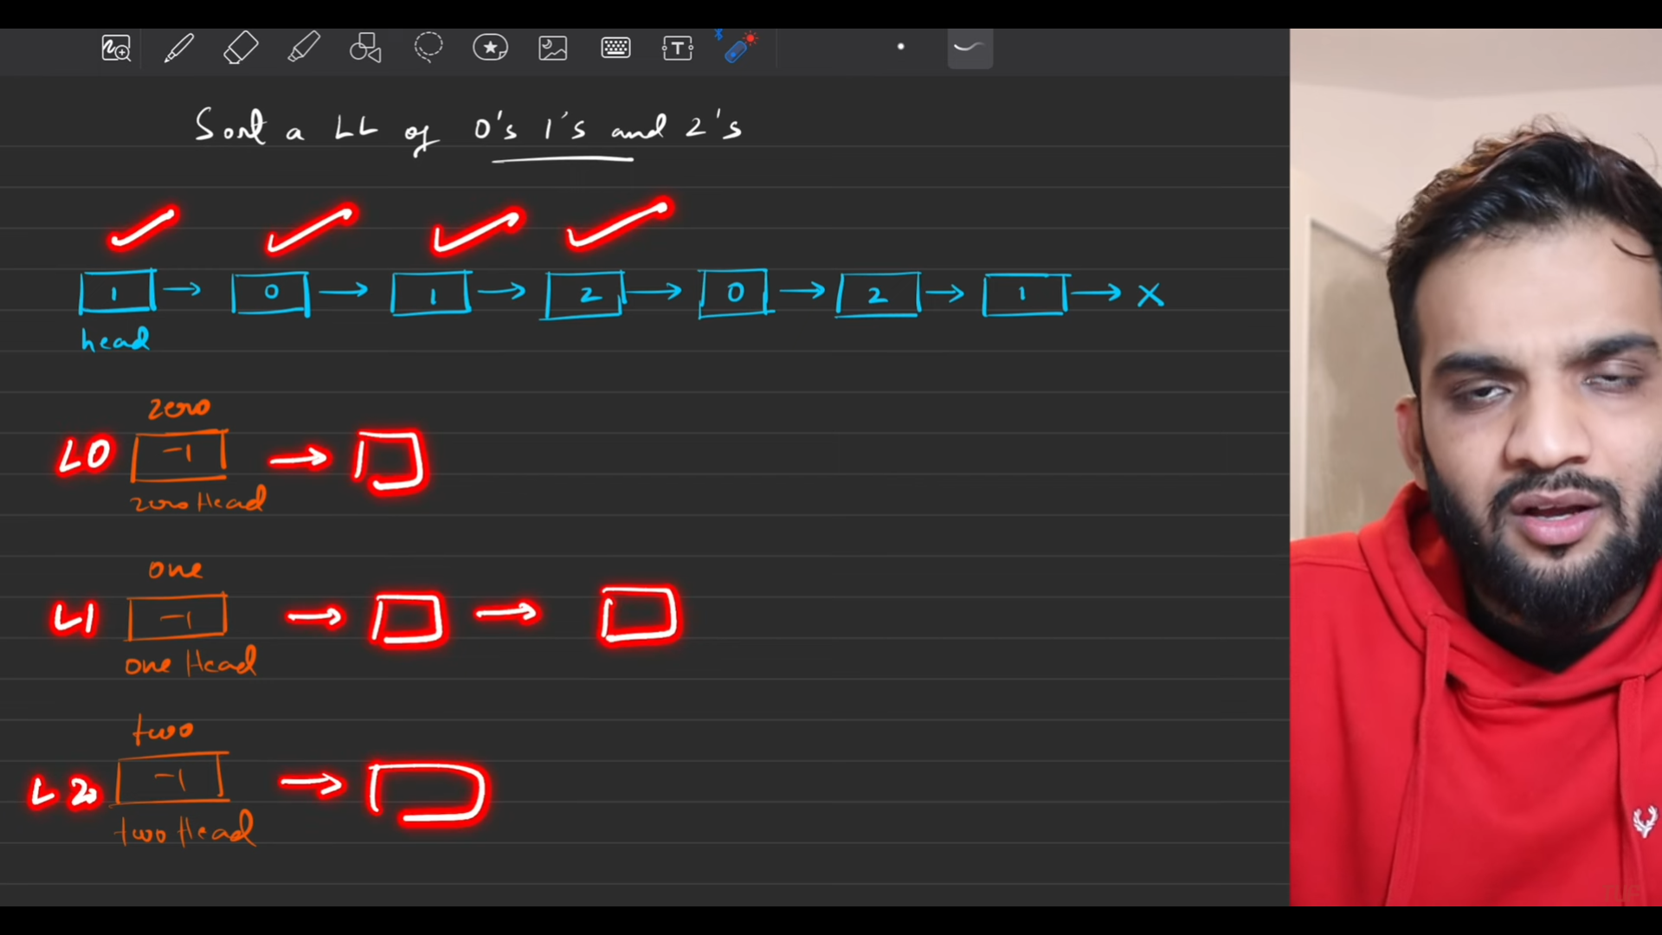
   8. 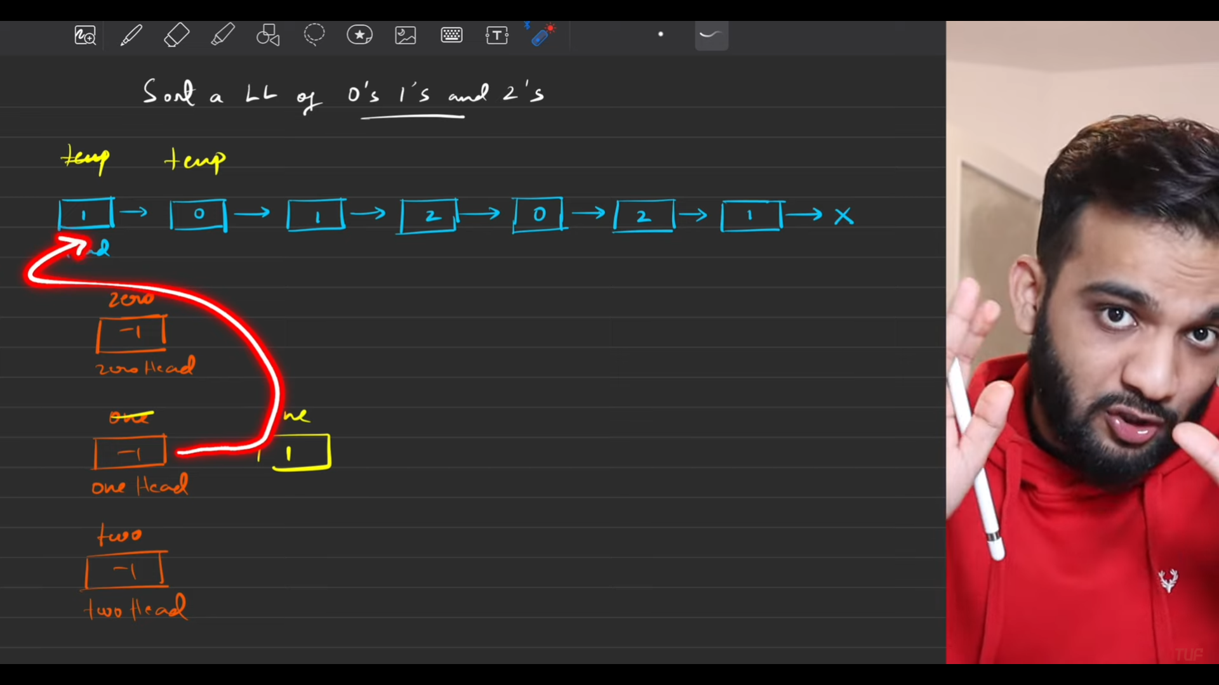
   9. 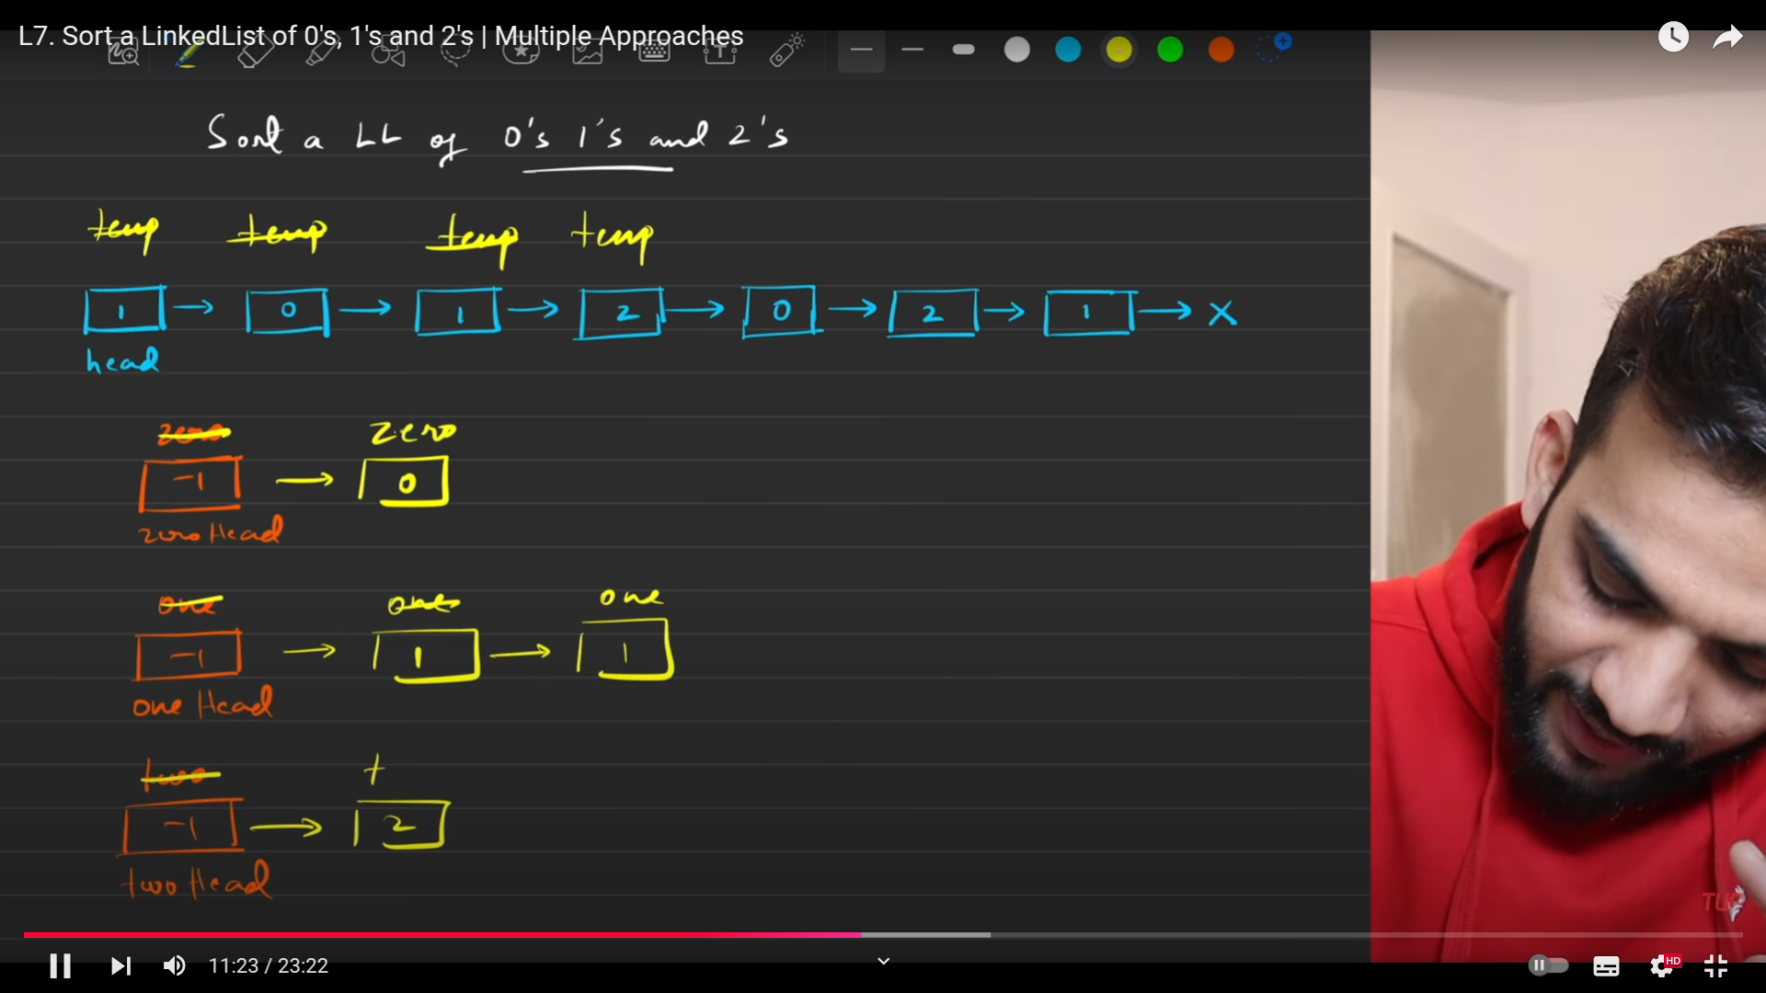
   10. 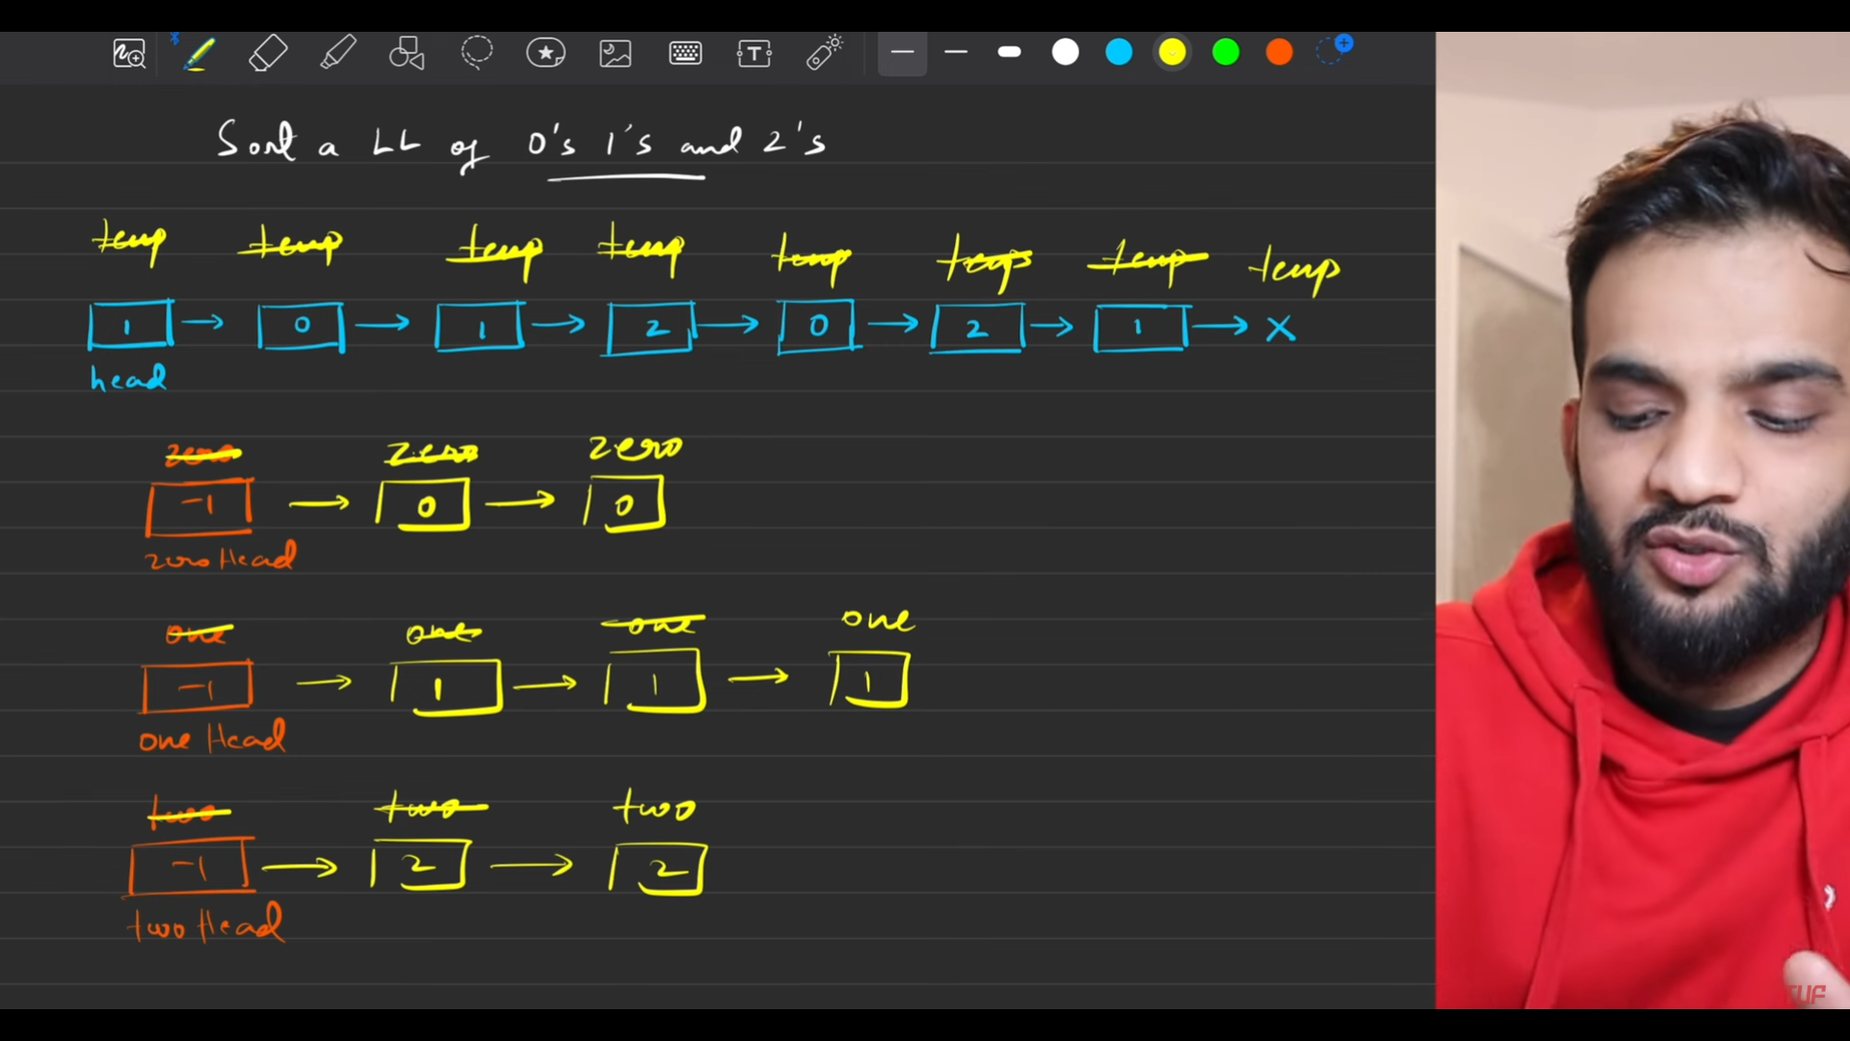
   11. 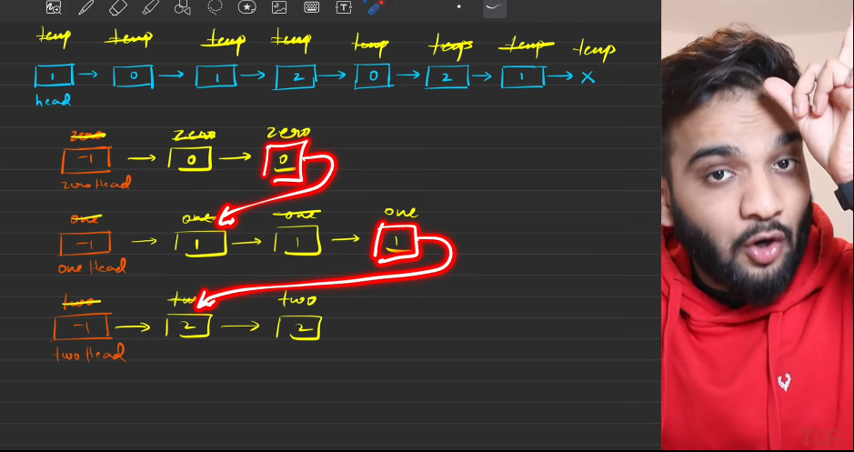
   12. 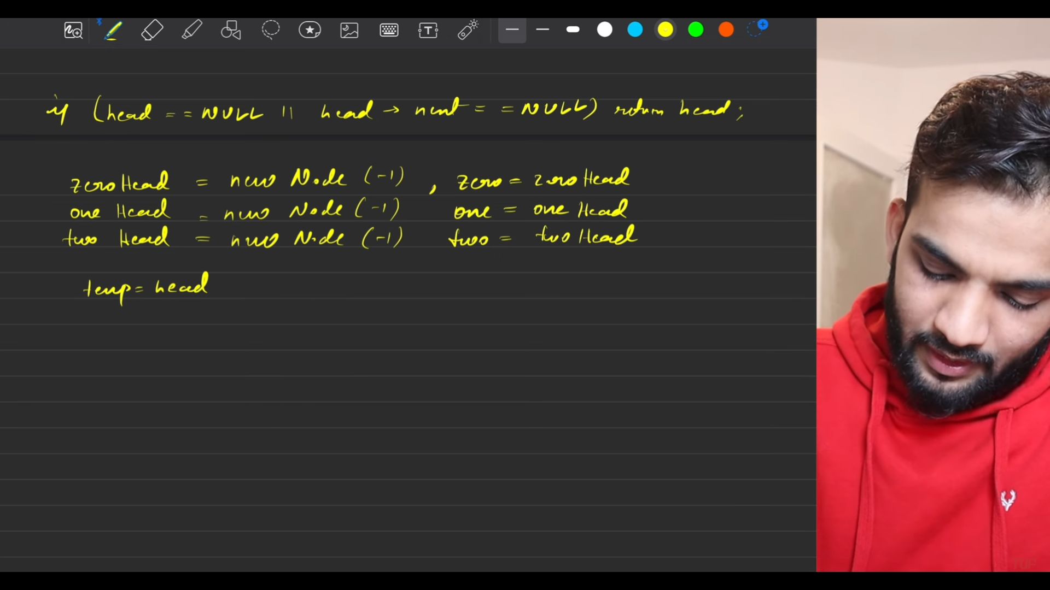
   13. 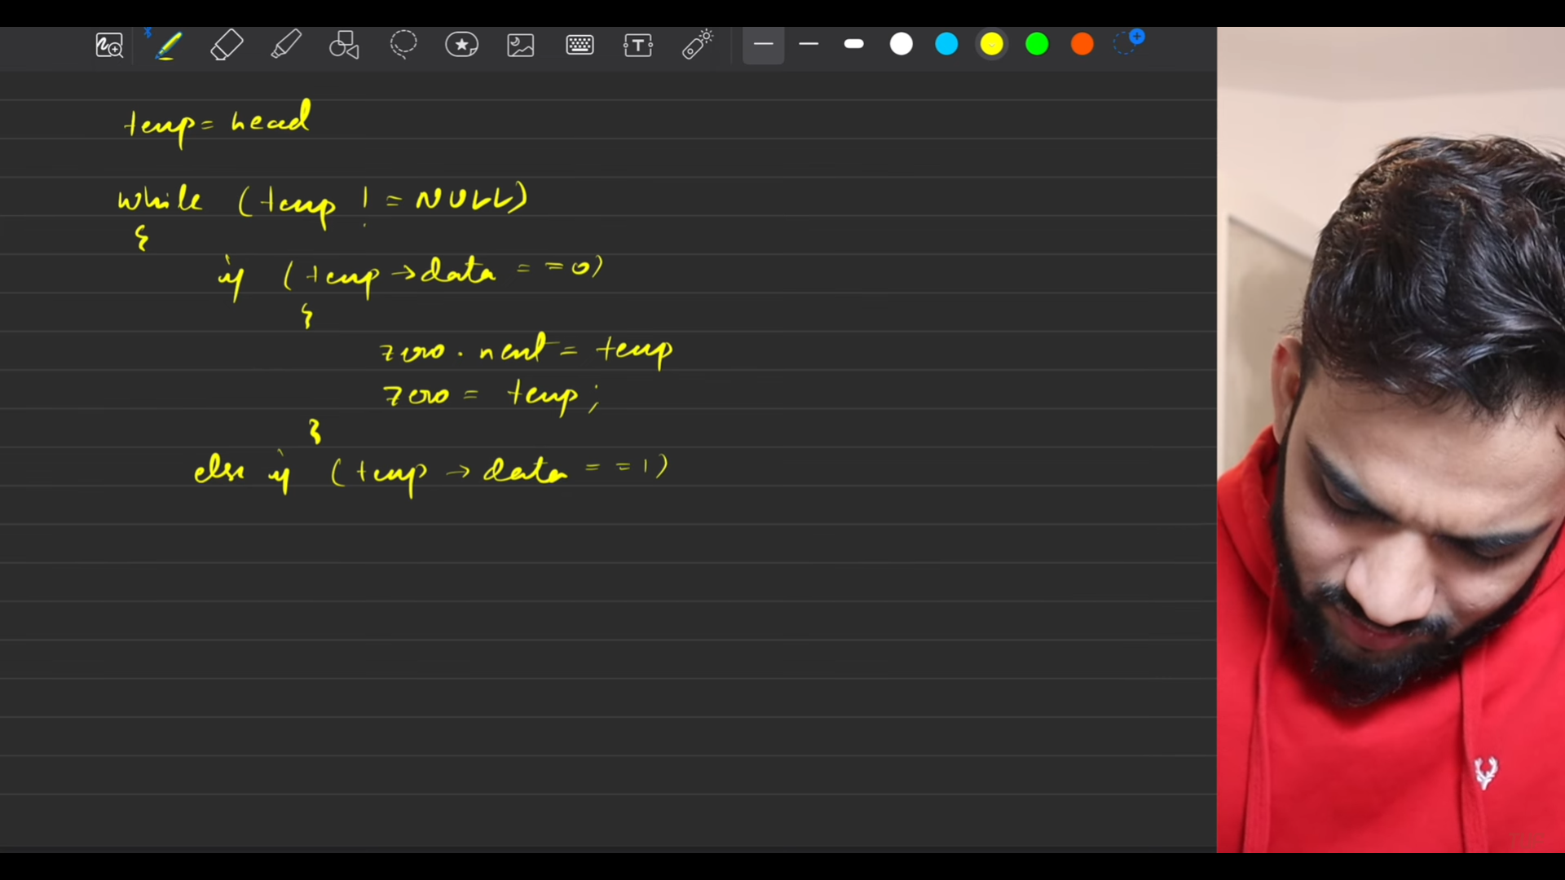
   14. 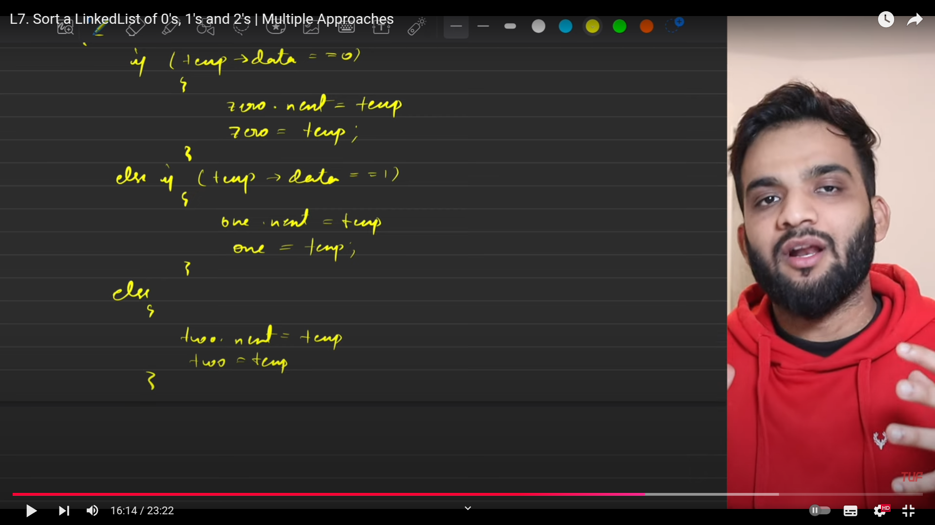
   15. 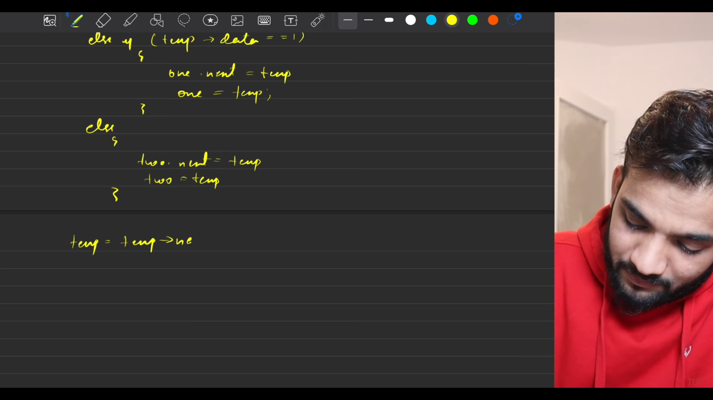
   16. 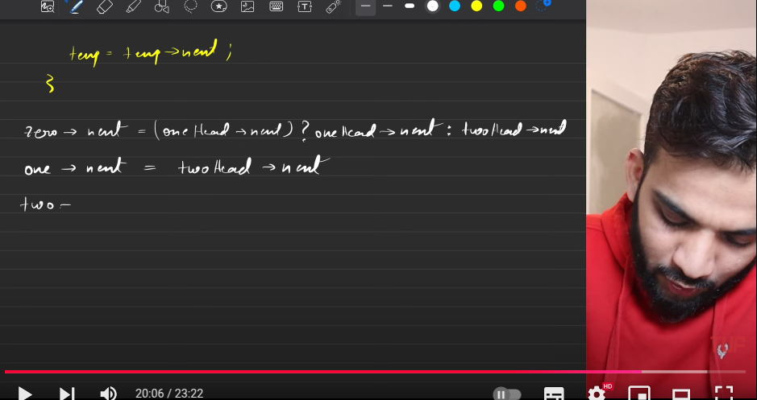
   17. 
   18. 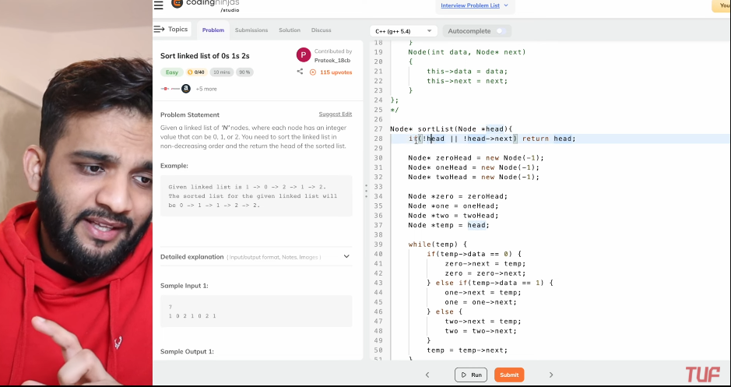
   19. 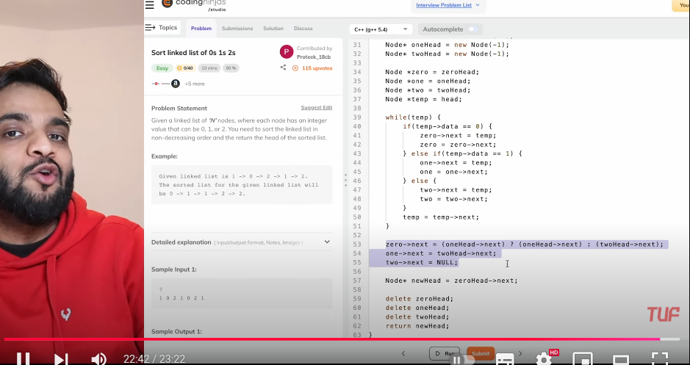
   20. 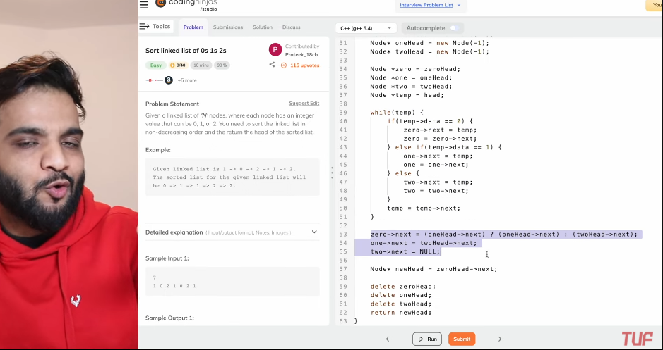

**Intersection OF Linked List Nodes**

* 1. 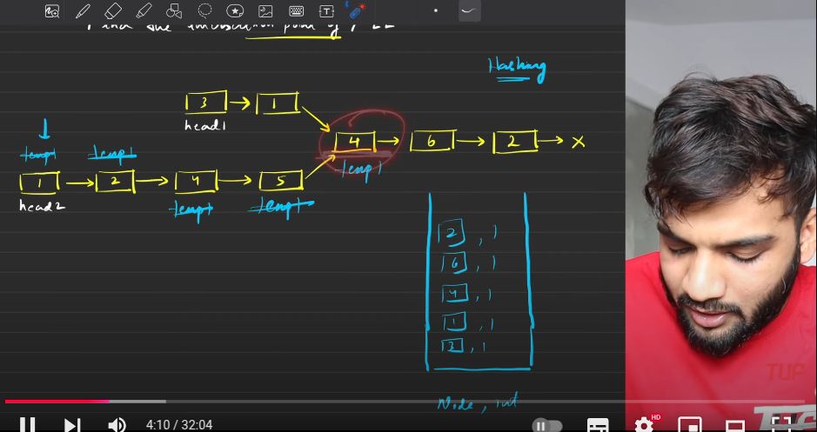
  2. 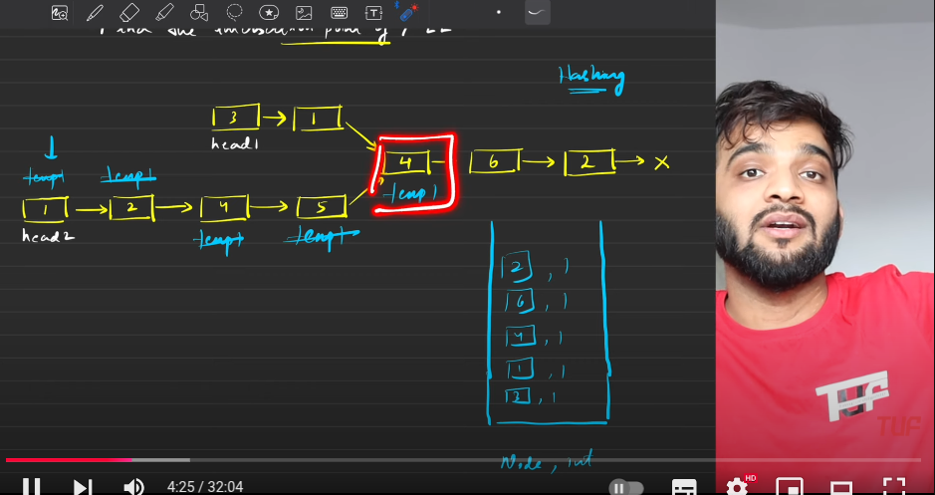
  3. 
  4. 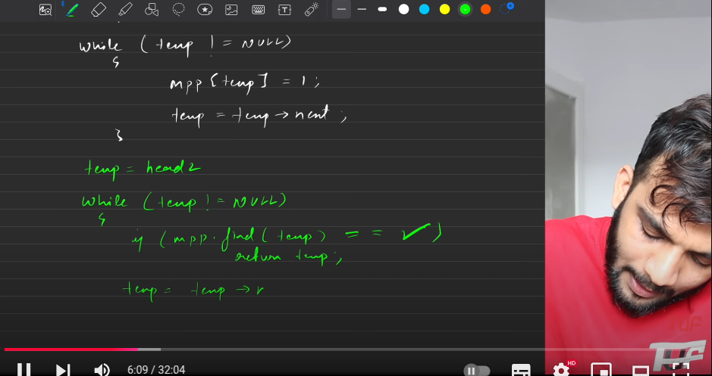
  5. 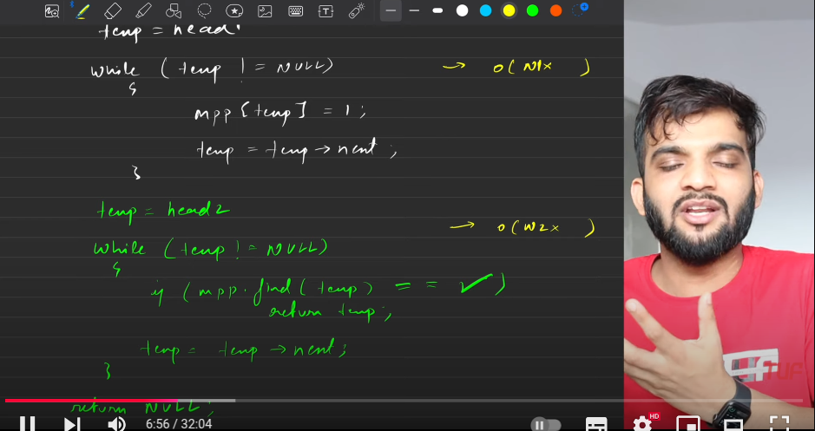
  6. 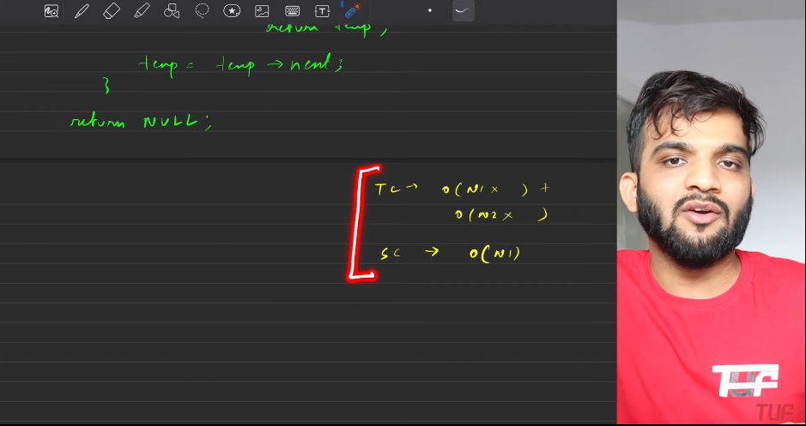

1. **In same number of traversals like above, but should not use the datastructure to load the nodes.**
   1. 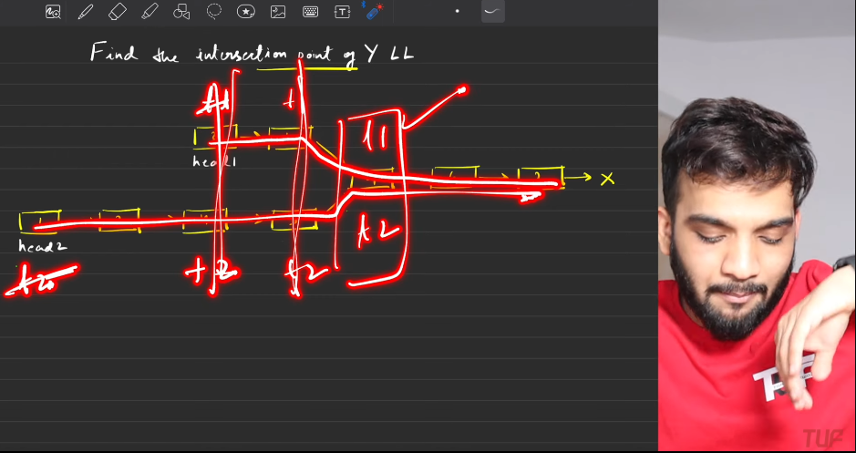
   2. 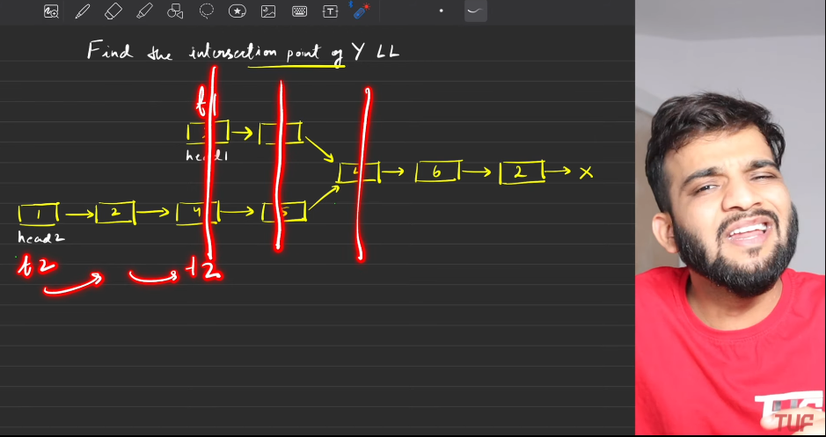
   3. First travel the longer ones for the difference in the length, then start to check whether they are mapping to the same node or not. SO need to travel the linked list for 2wice or 3rice.

**Add 1 to LL**

1. Understanding
   1. 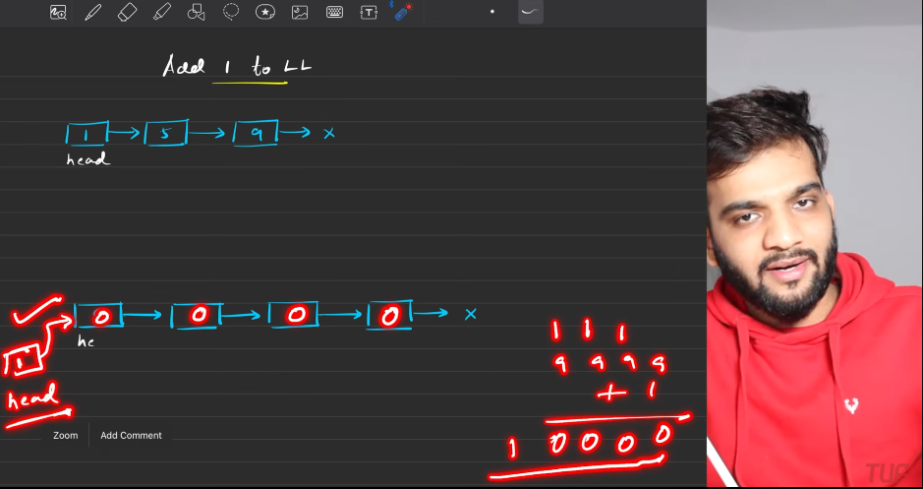
   2. 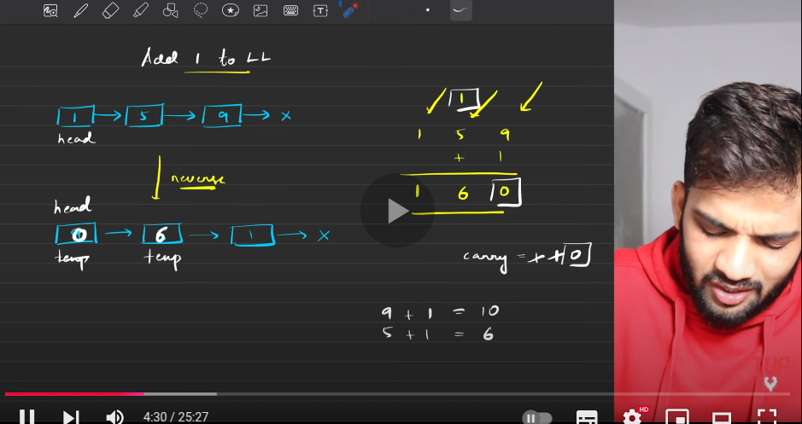
   3. 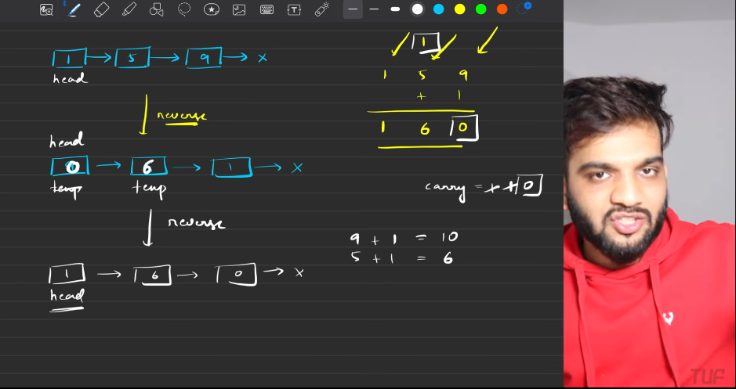
   4. 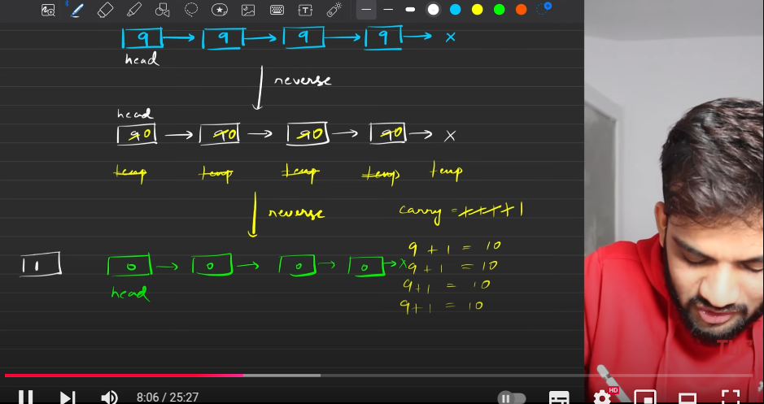
   5. The idea: Reverse the list and start appending 1 to it, till the list ends.
   6. When there is carry, then need to take the carry to the next element, if there is no carry then there is no need for it to take to the next level, you can stop changning the elemnts.
   7. Reverse the list again then return the head.
   8. 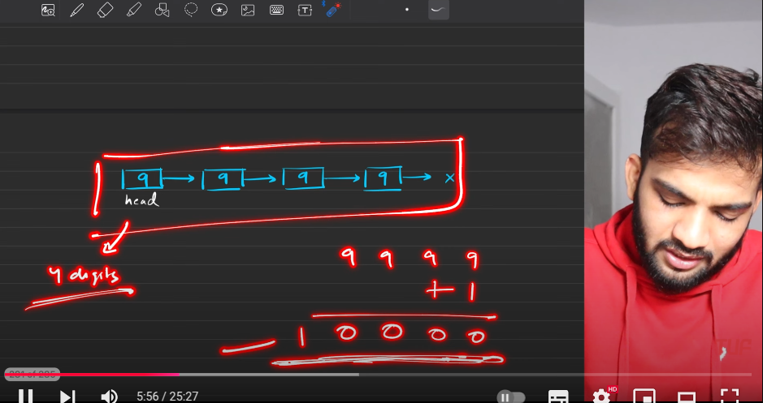
   9. 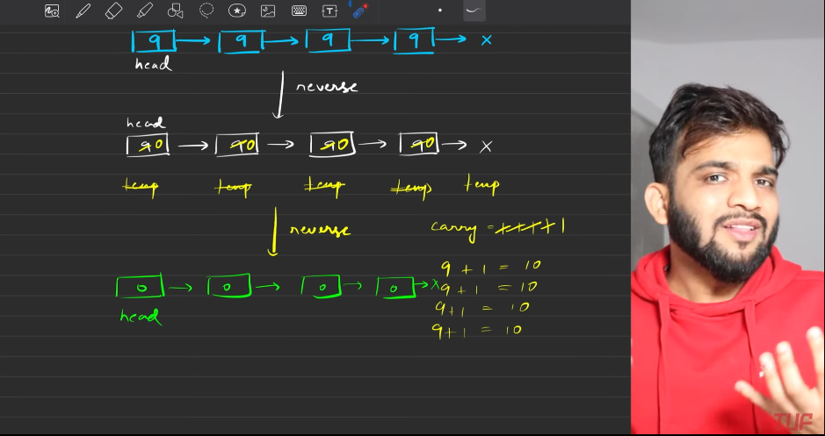
   10. 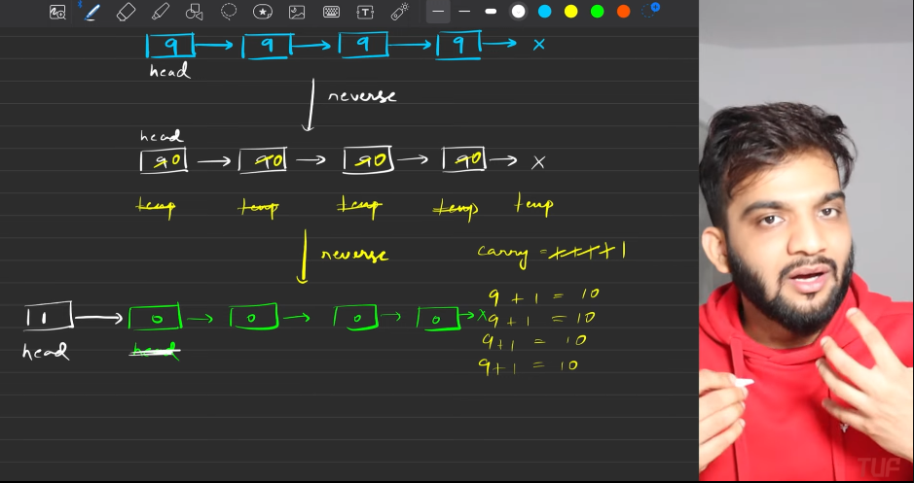
   11. 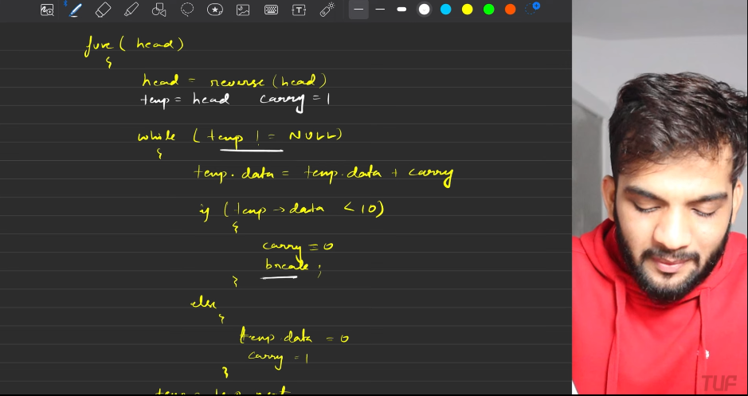
   12. 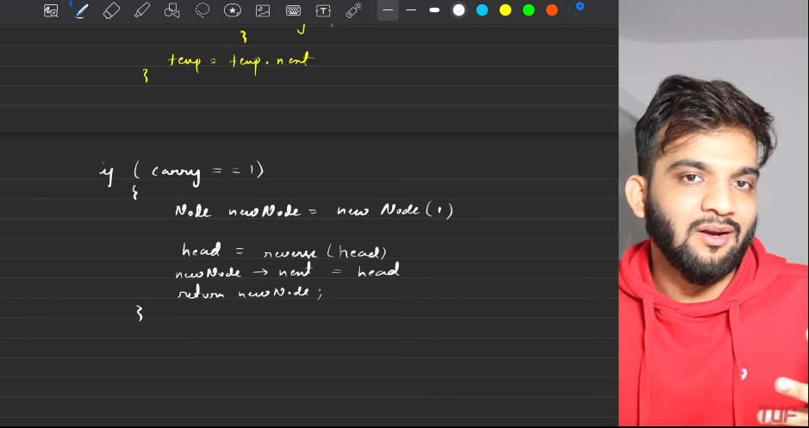
   13. 
   14. 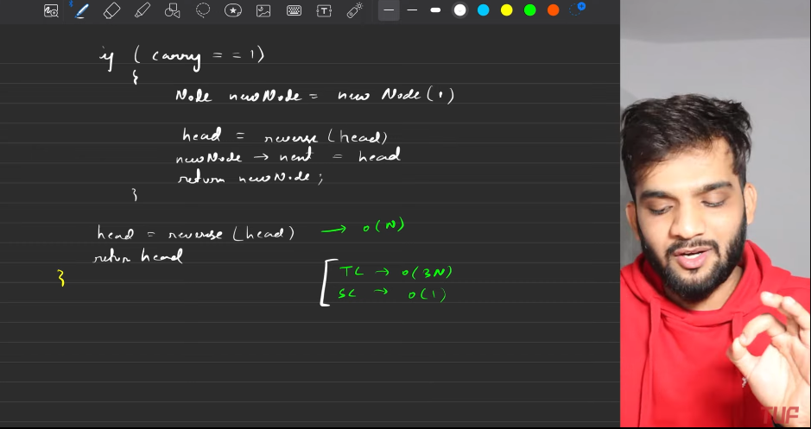
2. **Reccursion**:
   1. Call from man function, if there is a carry=1, then add 1 the node to the start of head, then return the node.
   2. Base case is reached when we are at NULL. So in those cases return 1. Since we need to add 1 at the end.
   3. Then Keep calling reccursion, based on the returned from the previously called function , if the adding results in more then 10, then we need to make return 1, after making the current node 0.
   4. Else return 0. Which will eventually follows up.
   5. 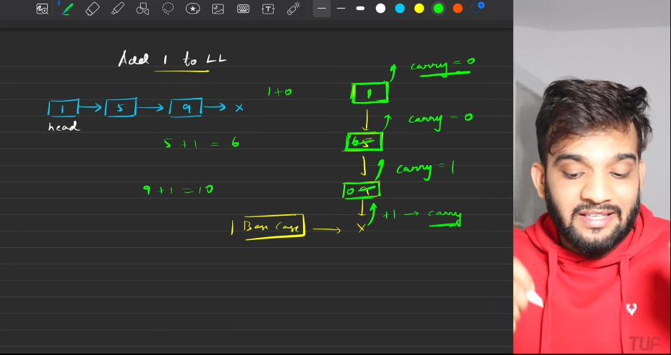
   6. 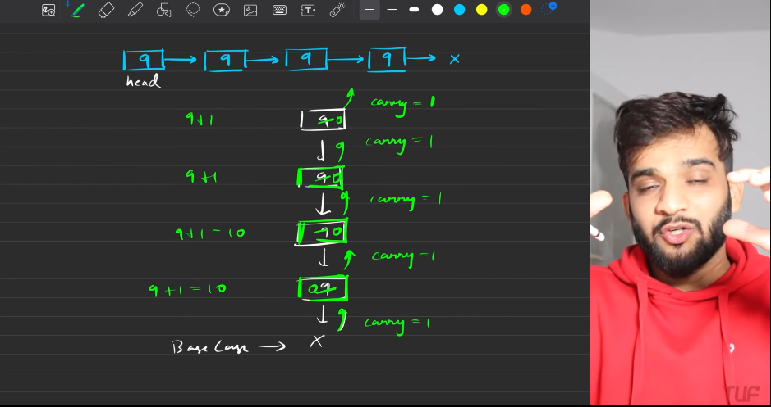
   7. 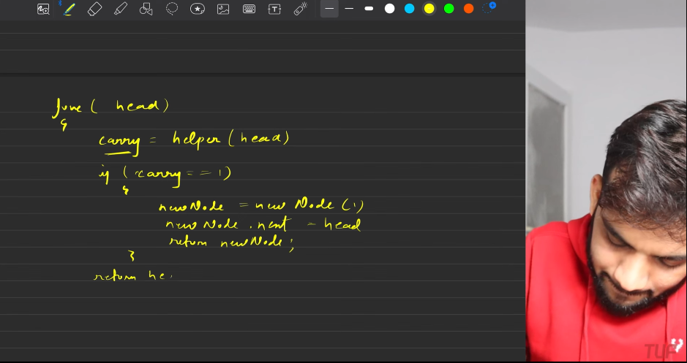
   8. 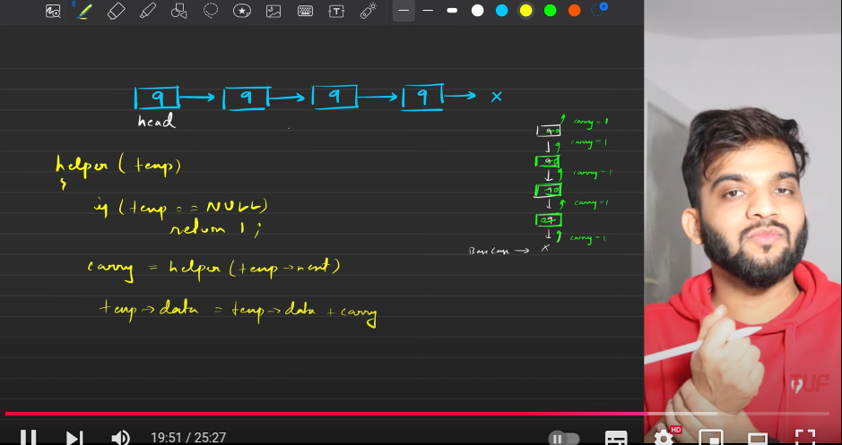
   9. 
   10. 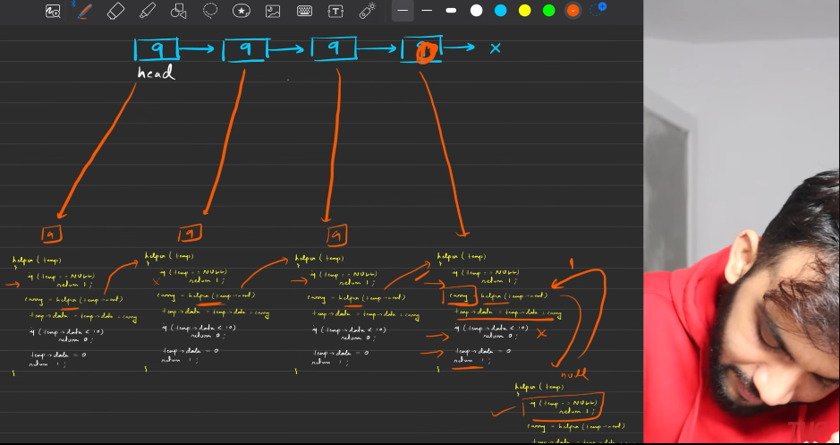
   11. 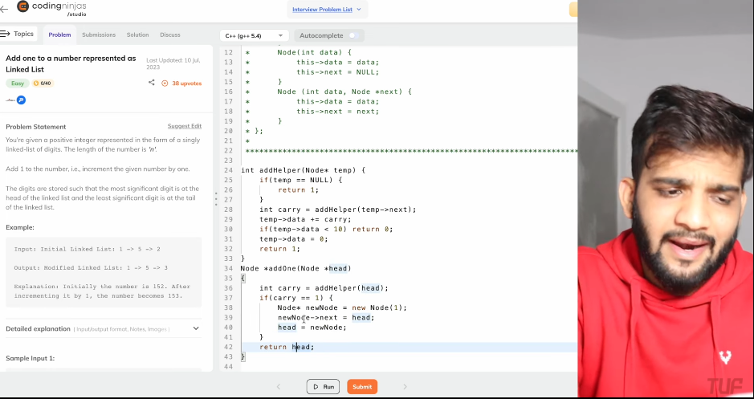

**ADD TWO NUMBERS IN LL**

1. Basically the 2 numers are given in reverse order. So the sum which should start from the lower index can now work simultaneously.
   1. **Remember**: Whenever you want to make new nodes list then it is better to create the dummy node, It prevents from making the messy codes.
   2. **Procedure**:
      1. You are given 2 lists in reverse order, which is nothing but lower orders at the first, then start adding the elements in the list and push that into the new node.
      2. When you are pushing, make sure you will be pushing the remainder of 10, carry is number got when divided by 10.
      3. Finally reverse(if needed, but in this case there is no need of it, as already the reversal of the numbers are given) and return the head.
      4. After the loop completes then , if we have carry then add a node which is carrying 1, hence it will be passed on.
   3. 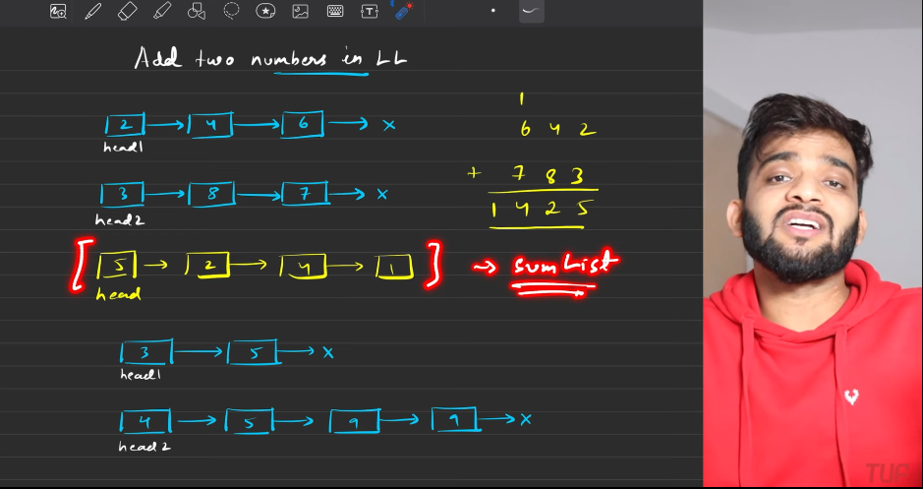
   4. 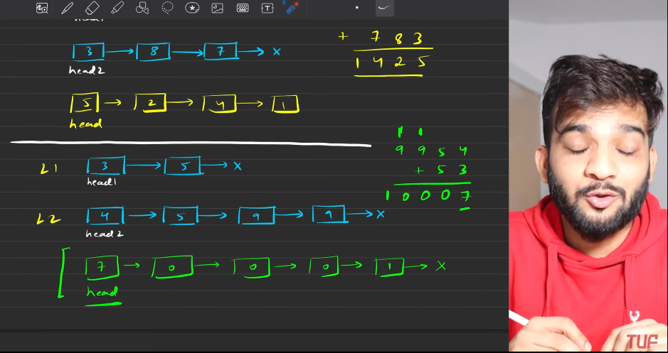
   5. 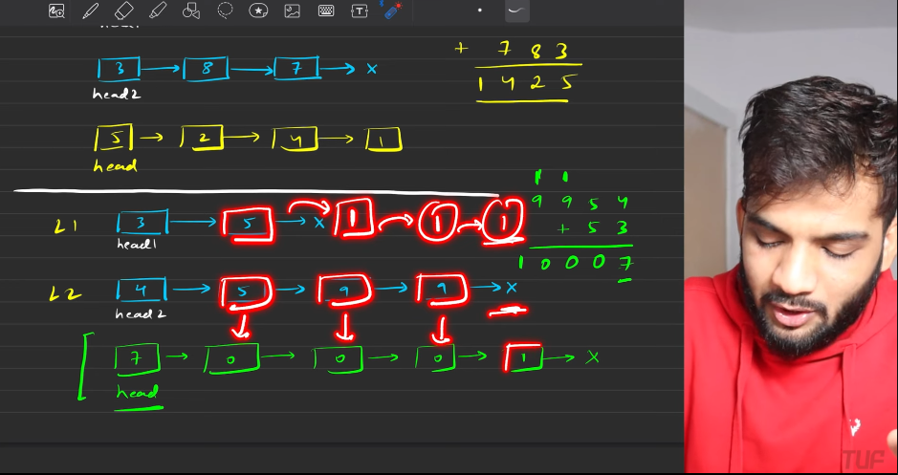
   6. 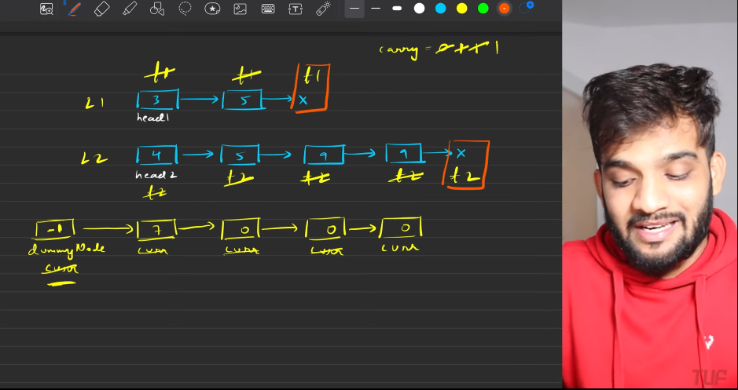
   7. 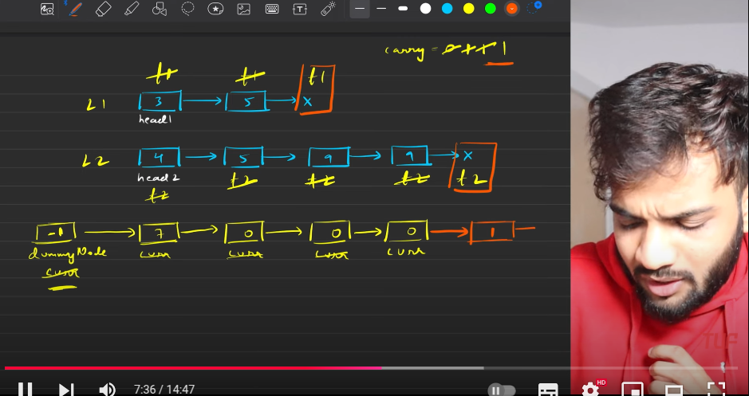
   8. 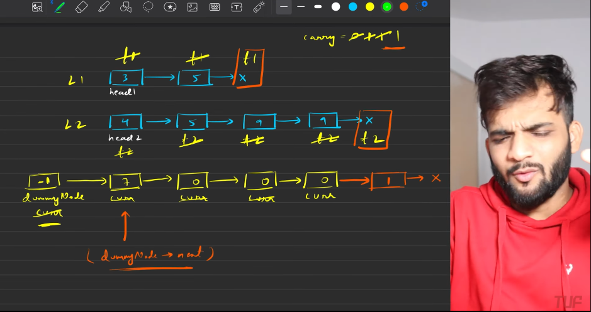
   9. 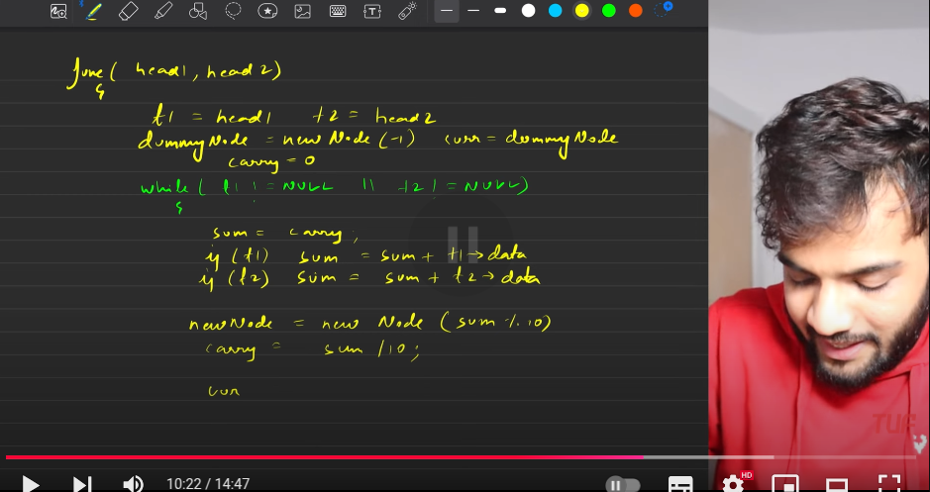
   10. 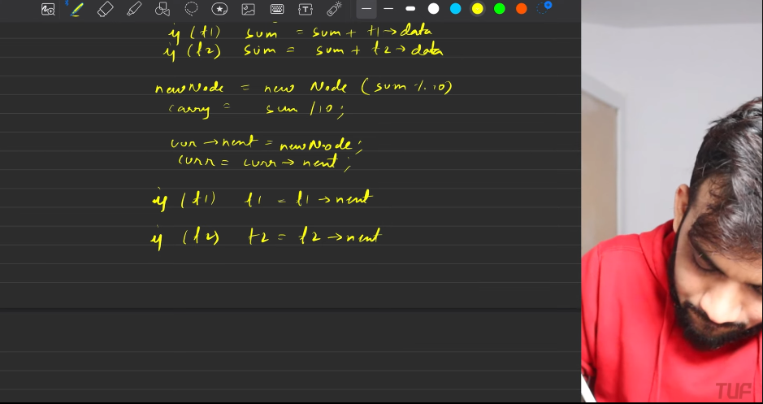
   11. 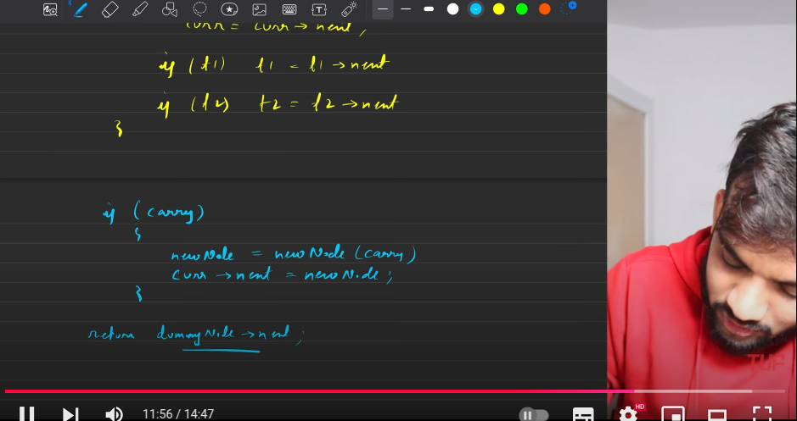
   12. 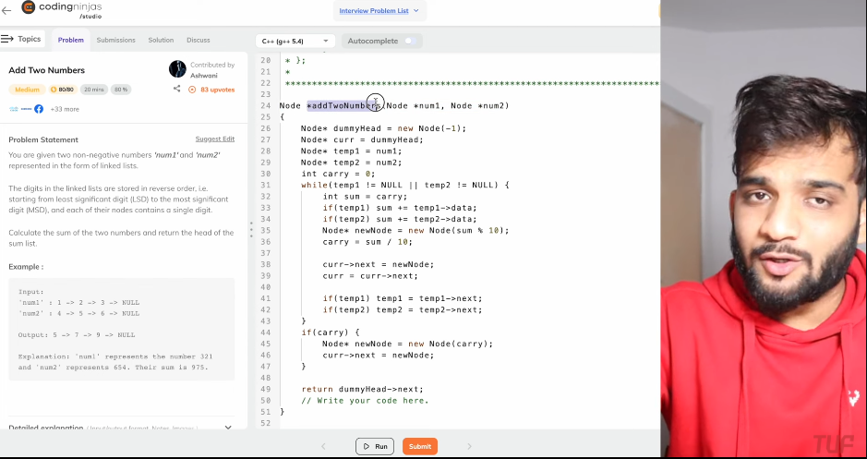
2. s